Update on Wigton Cemetery from Wigton Burial Joint Committee
July 2020
We are pleased to give an update on what has happened and is happening regarding the cemetery and hope everyone finds this useful.
Wigton Burial Joint Committee is made up of 9 councillors from 3 parishes - Wigton, Waverton and Woodside.
It is the only cemetery in Allerdale which continues to be independently operated.
Last year we were forced to entirely change the way the cemetery operated.

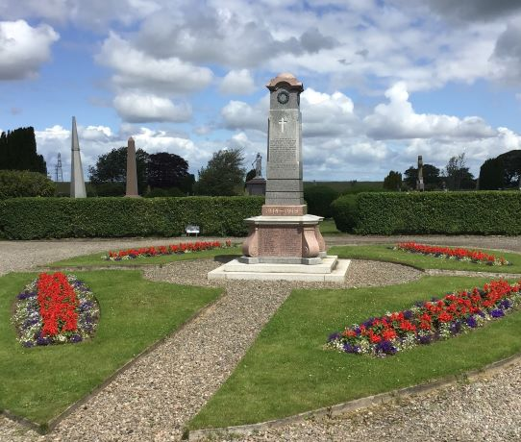
Finances and Agreement with Allerdale Borough Council:
Moving forward, the finances to manage the Cemetery will come from 3 major sources.
The first is the income from funerals, purchase of grave spaces and plaques in the Memorial Garden and the erection of headstones.
Secondly, we are very grateful for the grants which come from our 3 councils, Wigton, Woodside and Waverton and thirdly, a new source of income from the letting of the Cemetery House.

We are in the process of arranging an Agreement with Allerdale Borough Council Bereavement Services to provide curating services for the cemetery which will include arranging funerals, purchase of grave spaces, maintaining cemetery records and deeds etc. This has been delayed due to the coronavirus situation, but we are hoping it will be in place soon.

Grass Cutting and Maintenance:
During the past year we have faced many challenges - funding cuts, new working practices, flooding, drought and Covid19 to name but a few. Despite all these problems we strive to maintain the high standards expected of us.
We have appointed a new contractor - Ian Rumney of Solway Garden & Landscapes.
Together with his team he is working hard to keep the grass under control and will cut the hedges in the autumn.
The flower beds around the Cenotaph have been planted red/white/blue to commemorate the 75th Anniversary of V.E. Day.
The scales have been repaired and restored to The Angel on The Banks Memorial.
The Victorian Benches are in the process of being re-furbished and we hope to continue this project over the autumn and winter months. Work to prevent flooding along the paths also needs to be carried out.
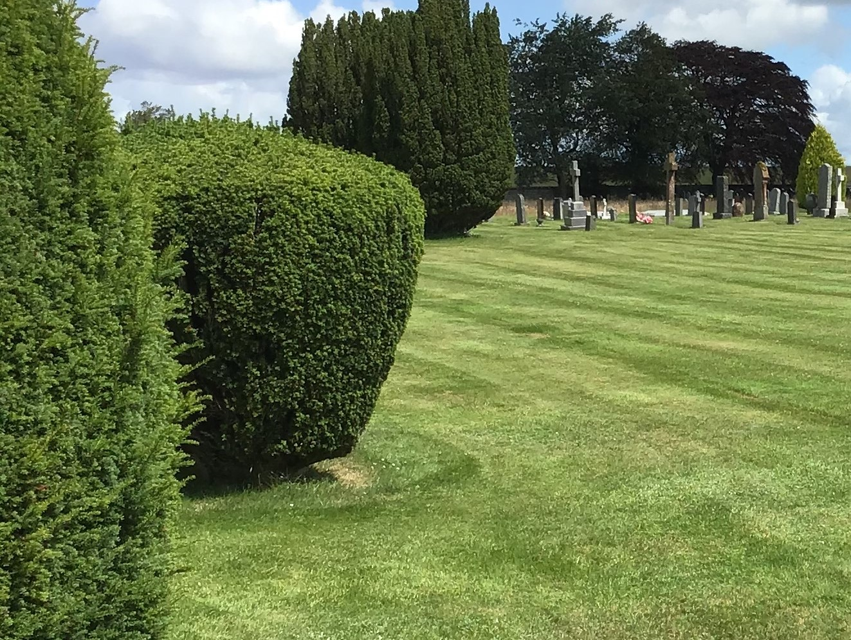

Safety Work on The Walls:
We recently carried out repairs on a section of the boundary wall which had become unsafe due to tree roots.
Importantly we were able to rebuild the wall without harming the ancient tree.
The Memorial Garden:
The Memorial Garden is a lovely addition to our cemetery where people can place a plaque in memory of their loved ones and have a quiet place to sit and reflect.
The Memorial Garden continues to be maintained by volunteers who are also preparing a Wild Flower Garden along the wall as well as clearing the beds behind the shed.
Quite a lot of work remains to be done but this work should be completed in the autumn.
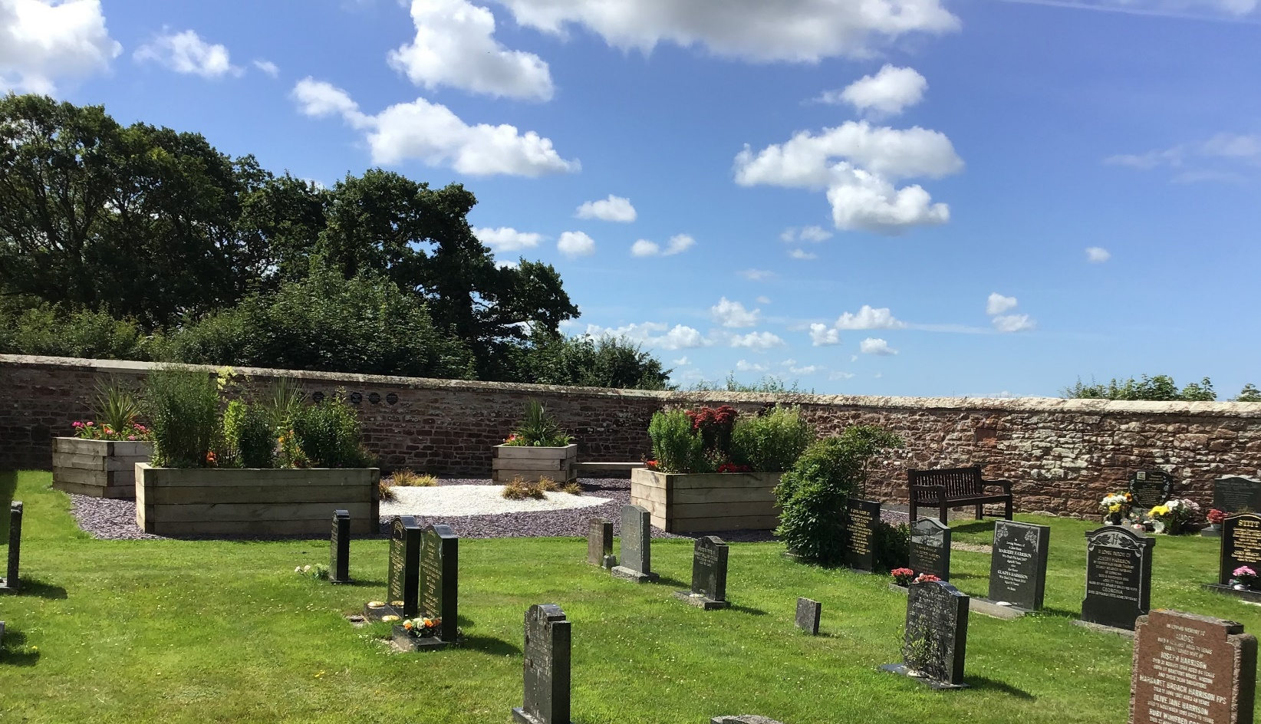
The Baby Memorial Garden:
The Baby Memorial Garden is being re-turfed and the flower bed re-planted.
The Friends of Wigton Cemetery:
The Friends of Wigton Cemetery continue to maintain the chapel and clear dead flowers and wreaths. They also maintain the toilets and area behind the sheds.
During the present epidemic the toilets are only open during funerals.
It is hoped The Friends will become officially constituted so they would be able to fund-raise. The first project would be to improve the area around The Cenotaph.
The Cemetery House:
There was an ideal opportunity when the house became vacant to implement a thorough schedule of necessary repairs, refurbishment & redecoration to a high standard to make it as attractive as possible to potential tenants.
We were fortunate to receive a Small Business Grant from Allerdale Borough Council and some of these funds are being invested in a comprehensive programme of works, using local contractors, suppliers and volunteers, which are soon to be completed.
It is a lovely big 3 bedroom house with amazing views and the rent from it will provide a valuable income stream towards the running costs of the cemetery.
The property is almost rental-ready and should shortly be offered to let through a local agent.
Meetings:
As we move forward, we intend to hold Committee meetings every quarter.
These will be held in the Vestry at the Cemetery where we will only be able to accommodate a maximum of six members of the public due to constrictions on space.
If members of the public have any questions for the committee, they can submit them in writing before the date of the meeting. Notice of meetings will be published in the noticeboard outside the Market Hall and on the Wigton Town Council website.
Due to coronavirus restrictions, we are not allowed to hold public meetings at present so will conduct our first meeting via Zoom.
This will be advertised shortly..
Appointment of a Clerk:
We will be advertising for a Clerk to Wigton Burial Joint Committee in the coming weeks to take care of the administration of the cemetery and the Committee, tasks which have been done on a voluntary basis by members of the Committee for quite some time.
Our key aims continue to be to keep the management of the cemetery within the control of the 3 local councils if we can and we are working tirelessly to this end.