A MEETING OF THE FULL COUNCIL WAS HELD ON
WEDNESDAY 10TH APRIL 2024 AT 7.00PM
PRESENT –
Councillor Chris Scott (Mayor and Chair)
Councillor Sandra Hodson (Deputy Mayor)
Councillor Mary Clark
Councillor Chris Stapley
Councillor Anne Jackson
Councillor Monique Speksnyder
Councillor Shane McCarthy
Councillor Mary Huntington
Councillor Mark Newton
Councillor John Hamblin

Clerk: Sophie Cooper

FC/01/2024 TO RECEIVE APOLOGIES & REASONS FOR ABSENCE
Councillor Ferriby
Councillor Meszaros
Councillor Crouch

FC/02/2024 MINUTES FROM PREVIOUS MEETING
The following minutes were agreed as accurate and signed by the Chairman:

Full Council held on 13th March 2024 – AGREED

FC/03/2024 DECLARATIONS OF INTERESTS, MEMBERS AND OFFICERS TO GIVE NOTICE OF INTERESTS ON ITEMS ON THE AGENDA

FC/04/2024 EXCLUSIONS OF PRESS AND PUBLIC

NONE

FC/05/2024 PUBLIC PARTICIPATION

To receive any representations from members of the public – Members of the public are invited to speak for a maximum of 5 minutes each. The maximum total time for public participation will be 10 minutes. At the close of this item, members of the public will no longer be permitted to address the Council Members unless invited to do so by the Chairman.

5.1 Public Participation

NONE

5.2 Cumberland Authority Report
Cumberland Cllr Lynch was in attendance and provided the following information:

Cllr Lynch informed members that Borderlands is back on track and another meeting is set for May. Projects that Wigton Town Council looked at a few years ago are currently being assessed by consultants. Cumberland Council are possibly going to have an event to see if the public like the ideas they have. Also, more engaging events to allow panel members to speak with people from different areas to see what they would like.

It was reported that Early Help for families is an area being worked on. Neurodiversity is also an area which is an issue and there had been a meeting the previous Friday regarding this, with people who are onboard to improve Early Help.

Cllr Hodson raised a concern with parents about wanting teachers to play down the SAT exams. Cllr Lynch mentioned that such a concern should be taken to the head of the school.

Cllr Hodson also mentioned that the monument should be cleaned, especially in preparation for D-Day. Cllr Lynch responded that the monument is an issue and is under Cumberland Council’s responsibility. Cllr Hamblin raised concerns regarding the monument needing repairs.

Cllr Lynch mentioned meeting with Highways regarding 20mph signs outside of the schools from 8:30am-9am and again from 2:30pm-4pm. In relation to the parking issues in the town, it was mentioned to erect bollards to try and prevent this issue.

Cllr Newton mentioned having electrical charging points in and around the town and Cllr Lynch responded that there is money in the budget for this.

Cllr Scott asked if there was any more progress with the grass cutting outside of Well Pharmacy – the grass will now be cut.

Cllr Lynch would like a no dog sign on the grass play area on Springfields.

FC/06/2024 Finance Matters

6.1 To receive and authorise Payments and Bank Reconciliation for March 2024

Members received the payment lists prior to the meeting.

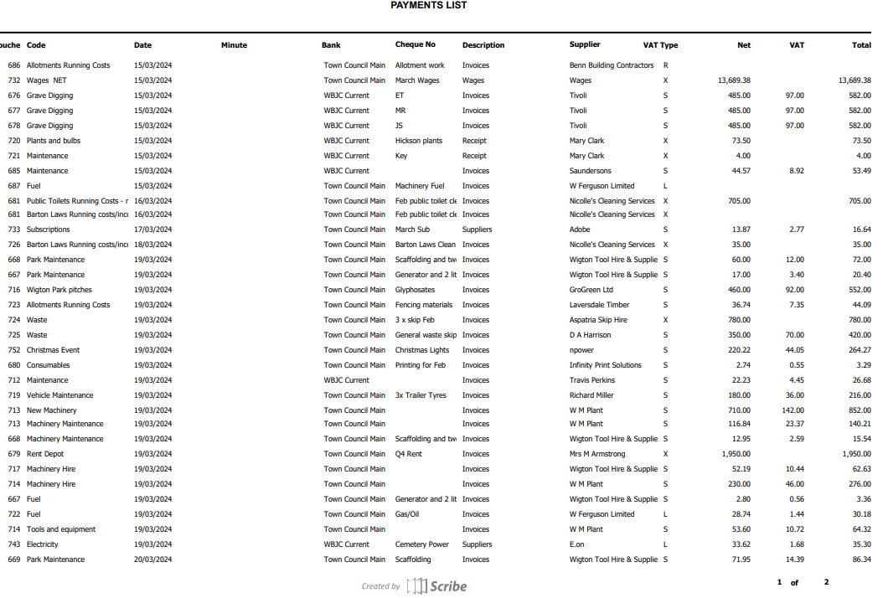

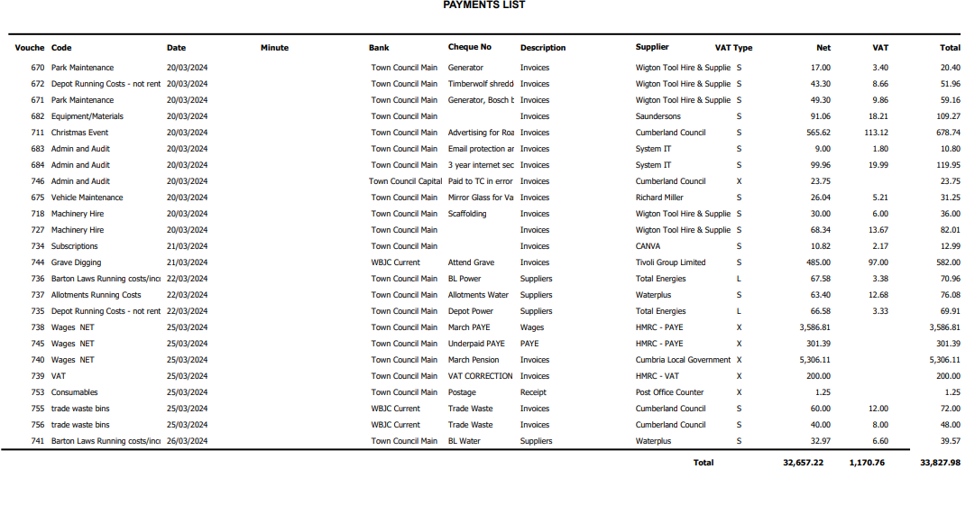

RESOLVED
Members approved all payments.

6.2 To receive the internal audit report

Cllr Scott stated that if any members had questions they were to ask SC to pass them onto EI, who would then answer them.

Cllr Clark raised a question about the unpresented payments and receipts and asked for the Clerk to answer what they are.

6.3 To discuss purchasing a portable hearing loop at the cost of £335.88
It was mentioned by Cllr Stapley that it is a requirement for this building to have a hearing loop. Cllr Scott highlighted that the Council having one would be useful for external meetings, like at Barton Laws. It was asked for it to be followed up to get a built-in hearing loop in the building – go straight to the trust.

Cllr Scott proposed to purchase the hearing loop, this was seconded by Cllr Jackson.

A vote was taken, and the result was UNANIMOUS

6.4 To consider donating money to the John Peele Theatre for their 60th anniversary

Cllr Hamblin mentioned Wigton Town Council should consider donating money to support the theatre as they are a part of the town, and it is their 60th anniversary. Cllr Clark mentioned they are a good asset to Wigton. Cllr Scott raised the fact they are struggling with ticket sales, so that could be an aspect Wigton Town Council could help with. It was suggested the Council advertise when they have shows to possibly push sales.

Cllr Stapley proposed a minimum donation of £200 and maximum of £600 to the theatre and the Chair and Clerk to decide an amount. This was seconded by Cllr Speksnyder.

8 in favour
1 abstain

FC/07/2024 Allotment Issues

Cllr Hamblin passed photos around showing fencing issues on some of the plots and expressed that the Council should take some responsibility, as in January 2023 it was wrote into the minutes that the Council is responsible for perimeter fencing. It was mentioned that a lot of the materials can be reused and that it is the posts that are the main issue.

Cllr Lynch mentioned the fencing backing onto the Infant School is the Council’s responsibility and Cllr Scott added the perimeter is the outer part of the whole section of land. Cllr Lynch went on to say that in the past, the individual allotment holder has always been responsible for their own fencing. Cllr McCarthy mentioned guidelines should be written, stating allotment holders should be responsible for their own fencing, apart from any perimeter fencing.

Cllr Speksnyder expressed the Council should not be responsible, but that they are an eyesore and went onto suggest if the allotment holders funded the materials, that Council staff could carry out the work. Cllr Newton mentioned that historically, allotment holders always looked after their own allotments. Cllr Lynch stated how allotment holders in Carlisle are responsible for everything themselves.

Cllr Hodson proposed taking the allotment rules to the Policy Committee to change and tighten up the rules, this was seconded by Cllr McCarthy.

A vote was taken, and the result was UNANIMOUS

A vote was also taken on whether to compensate the allotment holder of plot 9. The vote to not compensate was UNANIMOUS

FC/08/2024 Civic Policy

Cllr Scott read a section from CALC stating the roles of Mayor and Chair should not be separated and should be carried out by the same person. Cllr Jackson also expressed these roles should not be separated.

The policy was not to be changed.

FC/09/2024 Cemetery Report – Cllr Clark

Cllr Clark reported there were 22 funerals last year and none in the current month. The Cemetery are receiving a decrease of roughly 50% off their business rates, dated back to 2017. Assets of Wigton Town Council would come into consideration, affecting the business rates.

The Cemetery is holding a meeting on Wednesday 17th of April for people to see the plans for the renewal of the entrance.

FC/10/2024 Grounds Maintenance Report

Cllr Hamblin questioned why there were water drainage issues at Barton Laws – the Clerk is to ask Stephen.

FC/11/2024 Mayor’s Report

FC/12/2024 Clerk’s Report

There was no Clerk’s report.

FC/13/2024 Member’s Report

Cllr Hodson – Carnival meeting and Borderlands meeting. Also judged Easter bonnets and eggs at the Food Pantry.
Cllr Jackson – Mentioned the defibrillator that is missing from Miller’s Park and asked if the Council could possibly aid financially. Had concerns regarding the flooding at Burnside. Also passed on complaints about the conditions of the roads and road signs. Mentioned the area by the steps that lead to Co-op car park and how it isn’t a looked after area.
Cllr Speksnyder – Borderlands meeting and mentioned speaking to Cumberland Council representatives about the flooding at Burnside, and that the Council have assessed it and concluded the fencing isn’t causing the flooding.

Cllr Scott added the fencing is causing debris to build up, which is the main concern.

Cllr Stapley – Infant School Easter at the church.
Cllr McCarthy – Children’s Easter service

Cllr Hodson brought up the fencing at the Crofts allotments and how it should be the home owner’s responsibility.

Meeting Closed – 8:57pm
Date of next meeting: Wednesday 8th May

