A MEETING OF THE FULL COUNCIL WAS HELD ON
WEDNESDAY 8th May 2024 AT 7.00PM
PRESENT –
Councillor Sandra Hodson (Chairman and Mayor)
Councillor Anne Jackson (Deputy Mayor)
Councillor Mary Clark
Councillor Chris Stapley
Councillor Anne Jackson
Councillor Monique Speksnyder
Councillor Shane McCarthy
Councillor Mary Huntington
Councillor Mark Newton
Councillor John Hamblin
Councillor Chris Scott
Councillor Claire Meszaros
Councillor David Ferriby
Councillor John Crouch

Clerk: Emma Ireton

FC/14/2024 TO RECEIVE APOLOGIES & REASONS FOR ABSENCE

FC/15/2024 MINUTES FROM PREVIOUS MEETING
The following minutes were agreed as accurate and signed by the Chairman:

Full Council held on 10th April 2024 – AGREED

FC/16/2024 DECLARATIONS OF INTERESTS, MEMBERS AND OFFICERS TO GIVE NOTICE OF INTERESTS ON ITEMS ON THE AGENDA

FC/17/2024 EXCLUSIONS OF PRESS AND PUBLIC

NONE

FC/18/2024 PUBLIC PARTICIPATION

To receive any representations from members of the public – Members of the public are invited to speak for a maximum of 5 minutes each. The maximum total time for public participation will be 10 minutes. At the close of this item, members of the public will no longer be permitted to address the Council Members unless invited to do so by the Chairman.

5.1 Public Participation

Several members of the public attended the meeting to share their concerns over the issues with crossing roads in Wigton and to bring along their petition.

Concerns included the lack of access and uneven pavements for motorised mobility scooters throughout the town, the lack of crossing to the Co-op and issues getting to the bus stop in the centre of Wigton. Some suggestions from the attendees included having a flashing light or having CCTV. The petition was left with council members to sign.

A second member of the public attended to ask the Town Council to support Wigton Baths as they rely on funding to stay open. It was mentioned that the Town Council grant Wigton Baths £9000 per year but they would be happy to help support further where possible. H&S was also mentioned with the member of the public asking why H&S wasn’t a standard agenda item. It was explained that many of the issues that were raised were actually down to the Cumberland Council not the Town Council but the clerk would share more information by email after the meeting.

5.2 Cumberland Authority Report

Cllr Elaine Lynch was not in attendance but provided the following information:

Issues in Wigton

- The ‘river’ at the bottom of West Avenue is no more! I reported it to Highways (with photos) and it has been sorted. It was not an easy job and took a while to fix but it looks very good now. The potholes in Water Street have also been seen to.
- I have reported the potholes at the entrance to Manor Court (again with pictures which seems to make a big difference in their response) and there is a team assigned to this job so it should be sorted soon.
- I also reported the damaged soil pipe at the bottom of New Street to Environmental Health and the landlord has been told what he needs to do so that should be fixed soon as well.
- All the town centre line markings have now been done which I am really pleased with.
- I am now chasing up the bollards round the Fountain and the cleaning of the Fountain as well as getting more information on grass cutting. This is not proving to be easy but I am working on it!
- I have also been helping residents with social care and housing issues too.

Cumberland Council

- 11th April - I attended the opening of the first Family Hub in Whitehaven which is a great facility and heralds a new approach to helping families at a much earlier stage when they need it most. This model of Early Help will be rolled out across Cumberland in the coming months.
- 20th April - I visited Taste of Wigton which was a really successful event. Ellie did an excellent job again in organising this.
- I continue to have lots of meetings in my role as Executive member for Lifelong Learning and Development and am visiting schools and colleges as well.

Some comments to feedback to Cllr Lynch included:

- The Taste of Wigton event didn’t provide extra income for the local shops.
- It was asked why were the same pavements being dug up more than once by different broadband companies and why could works not be planned better?

FC/19/2024 Finance Matters

6.1 To receive and authorise Payments and Bank Reconciliation for April 2024

Members received the payment lists prior to the meeting and extra invoices were read out to members for them to approve.

Cllr Clark reminded the clerk that there was still an amount allocated to ‘petty cash’ which she felt shouldn’t be used. The clerk responded that petty cash was used over the last month which is why it had reduced and that the final amount would be paid into the bank at the first opportunity.

The payment list showed a payment to the Wigton Baths, a discussion followed with members enquiring into the finances of Wigton Baths with a recommendation that a meeting should be held to discuss issues with their funding.

RESOLVED
Members approved all payments.

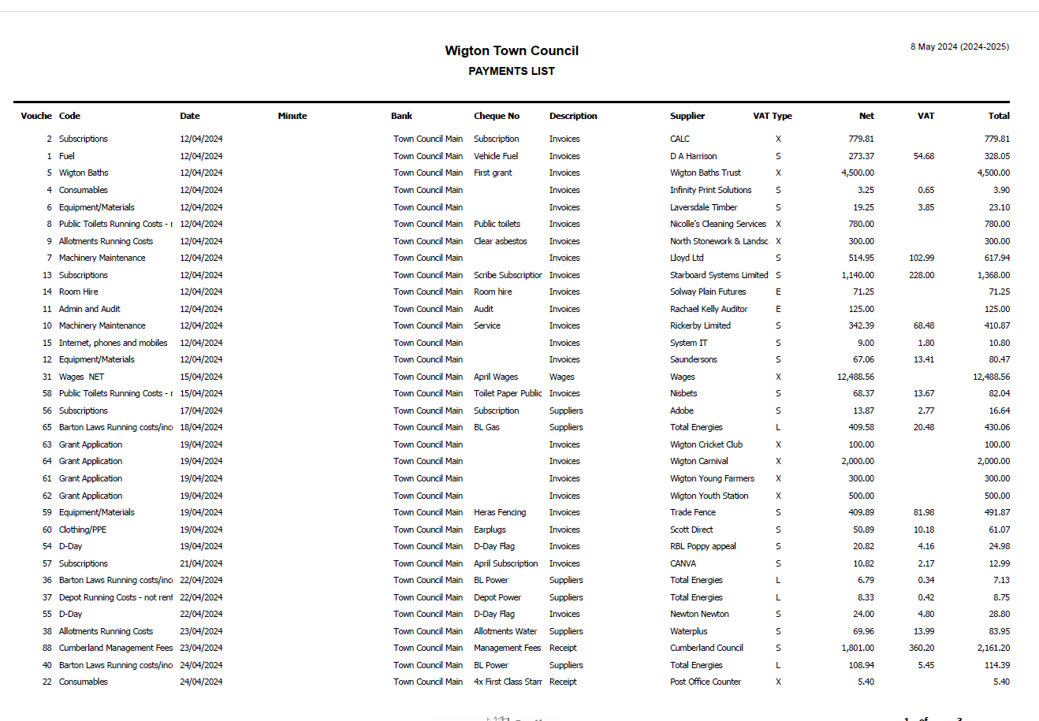

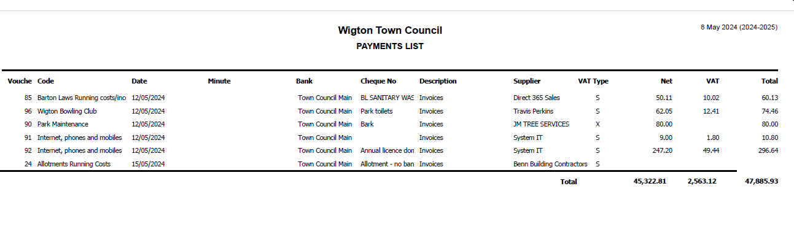

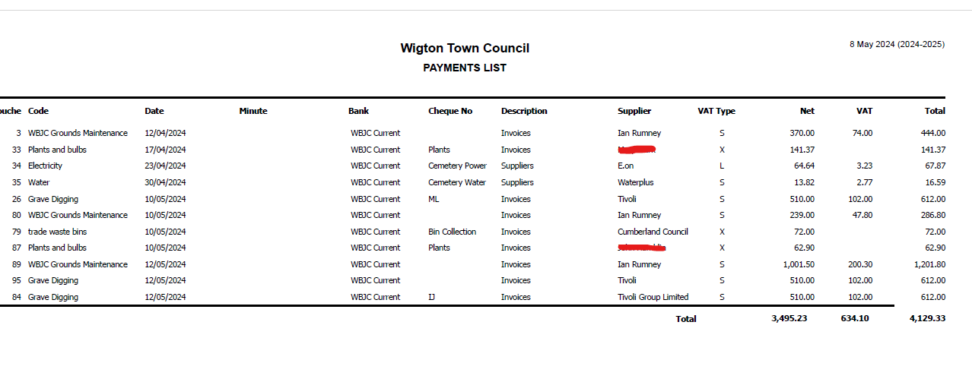

6.2 receive an update regarding year end accounts.

The clerk/RFO assured members that year end accounts were in hand and were due to be completed in advance of the 30th June deadline. The previous years accounts were being restated due to some updates being made to VAT and the cemetery house payments. The asset register for the town council and WBJC had also been updated.

FC/20/2024 Grounds Maintenance Report

A report was received by the ground’s supervisor prior to the meeting:

Barton laws/ park pitches:
All of the teams have finished there leagues now with the pitches standing up to a lot of games at the end of the season, thankfully it was decent weather . Some back end work is required on all of the pitches now getting a price of Tivoli . The park 9 v 9 pitch needs drainage work done asap; price needed.

Green portacabin :
We have got the Harris fencing now so we can start demolishing the portacabin and fence it off whilst work is undergoing (when we get time)

Longthwaite / croft allotments:
We erected a fence along the back of the croft allotments to stop the chickens coming in from someone's rear garden . Hopefully this stops them. Some fencing is still undergoing repair or renewal at the Longthwaite allotments.

Grass cutting:
We are now in full swing, but it has been a struggle on certain sites with the wet and warm winter we struggled to get on parts of the land with it being too soft, but we have managed now and all sites are cut regular (every fortnight) and the main field at the Nelson is cut every week, as agreed with the school.

Park toilets:

These are in desperate need of repair or replacing . It has been mentioned by quite a few members of the public using the park and bowling green, as these are public toilets used by everyone and are especially busy through the summer break . Signage is needed as well.

Spraying site:
This is ongoing but on the school sites we can only spray over the weekend when there are no children and teachers around this is for safety reasons .

Bus shelters:
These have been washed apart from the Syke road one which has road works/traffic light system along it and we cannot access them . It will be done when the road is back to normal.

Town/park benches: We are in the process of painting/treating the benches, but some have been finished and are ready to go out.

Summer bedding : I'm in the process of pricing up for the water street beds to be made into all year-round colour, just like what we done to Wigton park. With a small amount of summer bedding along the front for extra colour.

HAVS:
We have all completed our hand, arm and vibration course.

FC/21/2024 Cemetery Report – Cllr Clark

Cllr Clark reported there were three funerals in the last month.

The summer grounds maintenance had also started.

It was raised that contractors working at the cemetery had reported receiving some abuse from members of the public, the WBJC members would meet at their next meeting to discuss how to try and resolve this. It is understood that possibly members of the public were confusing contractors with the grave digging contractors as this is where many of the issues are.

Cllr Meszaros left the meeting at 19.37

Also reported was an update on the entrance improvements where it was noted that the drainage would need to be resolved before work could begin. All being well improvements will be complete by the end of the summer.

FC/22/2024 Hearing Loop Update

The clerk provided an update regarding the hearing loop that had previously been approved to purchase. It was found that the piece of equipment was only a amplifier and that the loop system would need to be hard wired into a room, it couldn’t just be plugged in. That would mean paying a specialist contractor to review the room and to provide us with recommendations. Discussed was if the Town Council made this purchase, where would it be installed? Within the NADT building with their permission or at an alternative site?

RESOLVED
It was agreed that a specialist contractor would be contacted to review rooms and then the information would be fed back to members to decide.

FC/23/2024 Mayor’s Report

No report.

FC/25/2024 Clerk’s Report

Reported the recent vandalism regarding the public toilets and explained a new door was required at the men’s toilets as the lock no longer works.

FC/26/2024 Member’s Report

Cllr McCarthy – Taste of Wigton and John Peel theatre
Cllr Stapley – Tate of Wigton and Rugby
Cllr Ferriby – Taste of Wigton
Cllr Speksnyder – Taste of Wigton and site visit to Black Beck
Cllr Jackson - Taste of Wigton and suggested a potential new councillor candidate.
Cllr Hodson – Planning D Day celebrations with RBL, Taste of Wigton and Abbeytown school exhibition.
Cllr Crouch – Planning a brunch at the Food Pantry on 5th June.

Meeting Closed – 8:53pm
Date of next meeting: Wednesday 12th June

