A MEETING OF THE FULL COUNCIL WAS HELD ON
WEDNESDAY 12th JUNE 2024 AT 7.00PM
PRESENT –
Councillor Sandra Hodson (Chairman and Mayor)
Councillor Anne Jackson (Deputy Mayor)
Councillor Mary Clark
Councillor Chris Stapley
Councillor Anne Jackson
Councillor Shane McCarthy
Councillor Mary Huntington
Councillor David Ferriby
Councillor John Crouch

Clerk: Emma Ireton

FC/27/2024 TO RECEIVE APOLOGIES & REASONS FOR ABSENCE
Councillor Monique Speksnyder
Councillor John Hamblin
Councillor Mark Newton
Councillor Chris Scott

FC/28/2024 MINUTES FROM PREVIOUS MEETING
The following minutes were agreed as accurate and signed by the Chairman:

Full Council held on 8th May 2024 – AGREED

FC/29/2024 DECLARATIONS OF INTERESTS, MEMBERS AND OFFICERS TO GIVE NOTICE OF INTERESTS ON ITEMS ON THE AGENDA

FC/17/2024 EXCLUSIONS OF PRESS AND PUBLIC

NONE

FC/30/2024 PUBLIC PARTICIPATION

To receive any representations from members of the public – Members of the public are invited to speak for a maximum of 5 minutes each. The maximum total time for public participation will be 10 minutes. At the close of this item, members of the public will no longer be permitted to address the Council Members unless invited to do so by the Chairman.

5.1 Public Participation

N/A

5.2 Cumberland Authority Report

Cllr Elaine Lynch was attendance and provided the following information:

Issues in Wigton

- Explained she had met with a Highways officer along with Cllr Hamblin to discuss a crossing to Station Road from the Spar area. The officer was interested in their views, also discussing a road safety petition. The plan is for the managers to visit and do a traffic census of vehicles and pedestrians at specific times of the day.
- It was also reported that the kerb outside B&M was too high so this was on the Highways waiting list to review.
- Bollards to be placed at the fountain are in the pipeline, a date was just needing to be set.
- It was mentioned that bollards may be placed at Tenters to stop vehicles and the Swimming bath staff may be able to open and close the entrance going to the baths.
- There has been complaints about the grass – which was cut last Saturday. A meeting is planned for the following week with Tivoli to plan a schedule.
- Weeds in Wigton had started to be removed.
- Met with officers regarding Wigton Baths who are going to try and help.
- The Cumberland Council are looking at having Community Hubs working with the Library and the Market Hall.
- Officers were going to meet to discuss grave digging at Wigton Cemetery.
- Elaine was looking into gifting copies of the Sheffield family to Dennis Graham.
- The next Community Panel is 24th June at 10:30 in the Market Hall.

Cumberland Council

- Visited the James Rennie new Sixth Form building and explained that SEND provision is looking to expand.
- Attended Carlisle College for the opening of their new construction shed.
- Advised that schools have been asked to join the attendance pledge.

Cllr Stapley mentioned a company that specialises in outdoor play equipment OPAL and asked if the local authority could make use of some of their equipment.

FC/31/2024 Finance Matters

6.1 To receive and authorise Payments and Bank Reconciliation for May 2024

Members received the payment lists prior to the meeting and extra invoices were read out to members for them to approve.

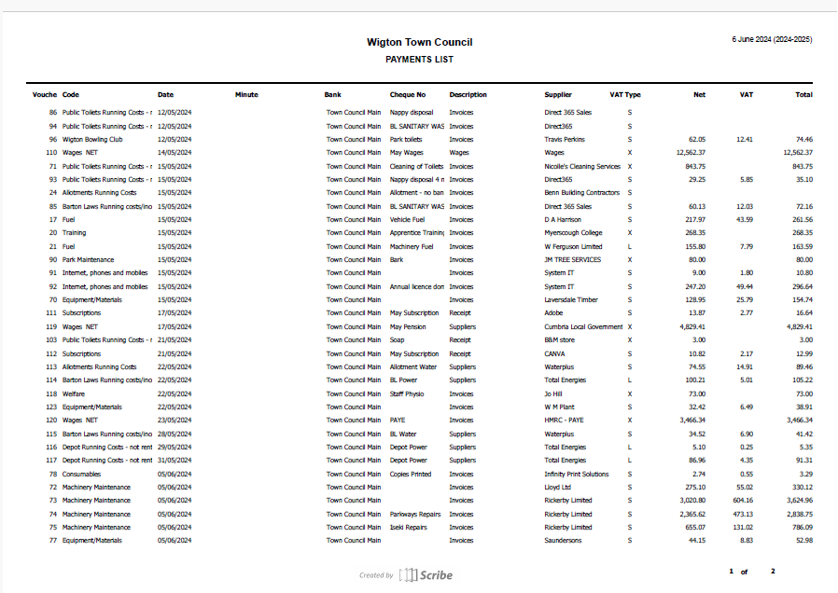

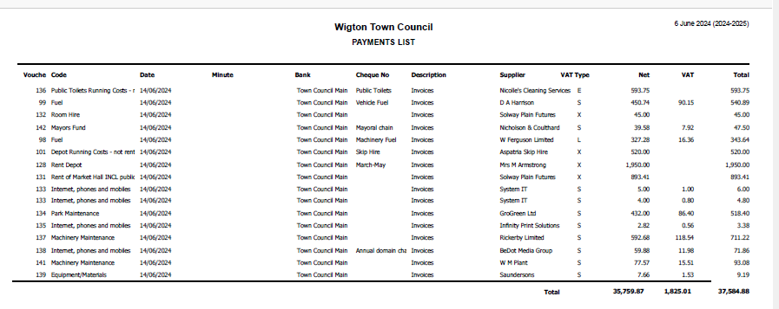

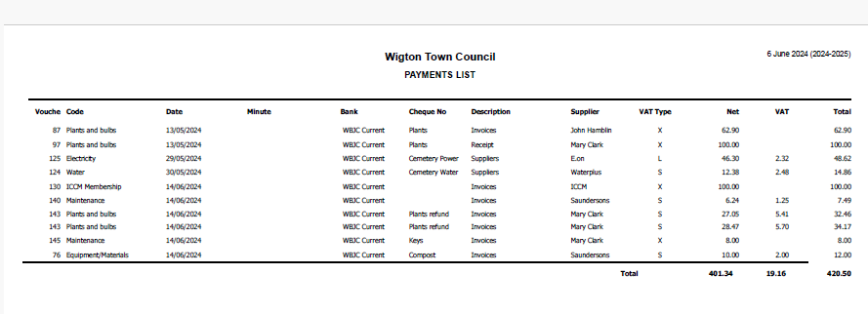

RESOLVED
Members approved all payments.

6.2 The clerk provided a first draft of the year end accounts but explained that the internal auditor report was required before full council could sign off so there would be an extraordinary meeting to sign them off next week.

6.3 The clerk provided members with a first draft of the new financial regulations but not all members had read the document so it was agreed to DEFER the new regulations and they would be taken to the extraordinary meeting.

FC/32/2024 Grounds Maintenance Report – Provided by Grounds Maintenance

We have been busy keeping on top of the grass cutting and weed spraying on all sites which has been difficult especially at the Nelson Thomlinson with all the exams as there are areas where we cannot cut through the day, so we have had to cut the areas first thing before they start or after school and even weekends.

We have planted up the Water Street beds with all year round colour and put mulch on which look tidy but I've suggested that we tidy up the seated areas on Water Street as they are a mess. Some of the plants in the park did not take so they have been replaced. The town flower tubs are ready as are the summer bedding for the rest of the planters around town, these will be planted up as soon as possible ready for carnival day.

The Football season has finished now and pre season work to be done by Tivoli which is planned for late June, but essential drainage work for the park 9 v 9 pitch and the area beside the new changing room on the main pitch must be put in the plans for the end of the next season ( June 2025) as these pitches get a lot of play and take their toll throughout the season .

There have been a few breakdowns this season which has made it difficult, especially with our strimmers as some of the machinery is getting old (10yrs) and need renewed as the cost of repairing is getting expensive like everything else. Our main machine is the random parkway which cuts a lot of sites is getting near the end of its life but these are very expensive (£45,000) so plans must be put in place to replace this in the future.
We have also pressure washed and regrouted the flags at the Stocksman war memorial which look good now.

FC/33/2024 WBJC Elected Members

Cllr Hodson was happy to relinquish her membership to the WBJC to Cllr Jackson who had been a member for several years.

Full council were all made aware and it was APPROVED that Cllr Jackson took this position.

FC/34/2024 Cemetery Update

It was advised that their next meeting was the following Wednesday where they have their annual walkabout prior to the meeting.

There had been 1 funeral since last month.
It was advised that the Cllr Girvan from Waverton PC was retiring and would no longer be their chairman, the new chairman for Waverton is now Cllr Huntington.

There is a meeting planned for Friday with Mr Leathers from the Cumberland Council to discuss the grave digging issues in Wigton.

FC/35/2024 Wigton Clean Up

Cllr Hodson asked if it would be possible to set up a ‘Wigton Clean Up Day’ for the coming weekend. It was discussed and was decided that more time is needed to plan an event such as this. This comes off the back of several resident complaints regarding the state of the paths and alleys in Wigton. Cllr Lynch agreed to speak to a Cumberland Council representative to ask if the paths in the centre of Wigton could be cleared prior to the carnival. A ‘clean up’ day could then be planned for the future.

FC/36/2024 Town Mayor’s Report

Cllr Sandra Hodson visited and supported the following:

- Watched Antics band film their music video
- Spent an evening with Redmayne’s and Eden Valley Hospice
- Joined the Young Farmers on their field day and walked some of the Cumbrian Way with them
- Attended the Wigton Baths meeting
- Was a guest on the new CRFM radio station
- Attended the Town meeting
- Supported the Hospice at Home Street collection
- Visited Innovia and CCL
- Joined the LAAL Collective at their puppet show
- Decorated the Fountain with Poppies for D Day celebrations
- Attended a plant sale for the Eden Valley Hospice
- Joined the Food Pantry for their Big Lunch
- Visited the 3rd Wigton Sea Scouts
- Attended Maryport’s D Day service

Cllr Hodson also requested we send a special thank you to Mike Armstrong for preparing the Beacon within Barton Laws.

FC/37/2024 Clerk’s Report
The clerk asked members if it were possible to purchase an annual parking permit for both the clerk and assistant clerk as neither lived in Wigton with the cost being taken from monthly salaries.

RESOLVED
Members voted to purchase the permits without them being repaid with 6 members voting to approve the purchase and 3 members voting against the purchase.

The purchase of two parking permits was approved.

The clerk added that the cost of the permits will be repaid monthly out of salaries.

FC/38/2024 Solar Lights

Cllr Jackson asked full council for their approval to purchase some solar lights that will be screwed to the walls at the Memorial Garden. The lights are in keeping with the area and supports the theme of the garden.

RESOLVED
Clerk authorised to purchase two sets of solar lights:
Tree of Life solar light- £27.99
Twin Pack of soldiers solar lights: £42.48

FC/39/2024 Member Reports

Cllr Jackson – D Day celebrations, Maryport D Day service, cleaning of the memorial garden, attended the Big Lunch, deal with complaints about the beck and Himalayan Balsan taking over.

Cllr Ferriby – Town Meeting

Cllr Stapley - D Day celebrations

Cllr Clark - D Day celebrations

Cllr Huntington - D Day celebrations, Organ recital and also asked about what jobs the grounds maintenance do as there were some at St Marys that needed to be attended to. The clerk offered to walk around with Cllr Huntington to get a better idea of the issues. Also raised a query over the timings of the flags and when they should be up and taken down.

Cllr McCarthy - Wigton Baths meeting and Innovia tour

Cllr Crouch - D Day celebrations, Town Meeting, Big Lunch and Laal Collective performance.

Meeting Closed – 8:42pm
Date of next meeting: Wednesday 10th July

