A MEETING OF THE FULL COUNCIL WAS HELD ON
WEDNESDAY 10th July 2024 AT 7.00PM
PRESENT –
Councillor Sandra Hodson (Chairman and Mayor)
Councillor Chris Stapley
Councillor Monique Speksnyder
Councillor Shane McCarthy
Councillor Mary Huntington
Councillor David Ferriby
Councillor John Crouch

Clerk: Emma Ireton

FC/40/2024 TO RECEIVE APOLOGIES & REASONS FOR ABSENCE
Councillor Anne Jackson
Councillor John Hamblin
Councillor Mark Newton
Councillor Chris Scott

FC/41/2024 MINUTES FROM PREVIOUS MEETING
The following minutes were agreed as accurate and signed by the Chairman:

AMENDMENT - Minutes from 12th June were missing the clerk’s report
AMENDMENT – EOM minutes Cllr M. Huntington did not abstain from voting, change to NO.

FC/42/2024 DECLARATIONS OF INTERESTS, MEMBERS AND OFFICERS TO GIVE NOTICE OF INTERESTS ON ITEMS ON THE AGENDA

FC/43/2024 EXCLUSIONS OF PRESS AND PUBLIC

NONE

FC/44/2024 PUBLIC PARTICIPATION

To receive any representations from members of the public – Members of the public are invited to speak for a maximum of 5 minutes each. The maximum total time for public participation will be 10 minutes. At the close of this item, members of the public will no longer be permitted to address the Council Members unless invited to do so by the Chairman.

5.1 Public Participation

A member of the public who is also a parish councillor for another council was in attendance to ask members of Wigton Town Council several questions in relation to the current financial regulations. While they were a parish councillor they were just in attendance as a member of the public. There was a lot of information read out by the member of the public, which resulted in asking members to raise their hand if they were aware of several points stated in the current financial regulations. Several Wigton Town Council members explained that they were not able to answer these questions immediately as they had not had the time to look over or scrutinise the financial regulations. It was agreed that the questions the members of the public had, would be left with the chairman of Wigton Town Council who would respond in due course

5.2 Cumberland Authority Report

Cllr Elaine Lynch was attendance and provided the following information:

Cllr Lynch firstly expressed her delight with having 3 Labour MPs for the area and a Labour government, she stated that they will likely be held to account to get the best for Cumbria. It was also suggested that we invite a Labour MP to Wigton to discuss current issues.

Bill Lowther’s passing was sadly mentioned with his funeral being on the 23rd July 2024.

In relation to education, the SEND provision will be looked at along with the funding of each child to ensure it is fair.

One of the biggest ongoing issues in Wigton is the traffic and highways problems so members received an update regarding these issues:
- A new team leader for Highways has been announced and it is this person who will be in charge of placing the bollards at the Fountain. The bollards work is due to be completed in November 2024.
- The dropped kerb outside B&M which is too high is going to be lowered over the next month or two.
- It has been proposed that a crossing is placed near the Throstle’s Nest to allow people to cross safely. Before this can be discussed, more information is required so a traffic cam may be installed to monitor the area.
- 20mph lights should be ready in September

Other issues in Wigton include the grass cutting and maintenance of the paths and roads. Cllr Lynch explained that the grass cutting that the Cumberland Council is responsible for will be undertaken three times per year and one cut had recently been completed and this included the area outside the GP surgery. It was noted that there was a call for the grass cutting schedules to merge so that the Cumberland Council and housing associations would all cut the grass at the same time across Wigton. Cllr Clark explained that the area around New Street and the old Police station still had not been touched and it was looking very uncared for.

It was stated that Wigton in on the list for the ‘Big Clean Up’ which other towns have benefitted from.

On to the Fells and Solway Community Panel, there were several organosatons that were awarded grants:
- Wigton Burial Joint Committee were awarded £4000 for the entrance improvements.
- The John Peel Theatre were awarded £2500 for CCTV.
- The Friends of St Cuthberts were awarded £1000
- Watchtree were awarded £3700 for board walks.

The Local Links are coming back as community hubs so they are looking for a place in Wigton to host them with the options being the library as well as other buildings.

Cumberland Councillors reviewed the home school transport system and managed to save half a million pounds which was much needed as the Cumberland Council need to save money overall.

Wigton Councillors then asked Cllr Lynch questions which included:
What was happening in relation to people parking outside the Spar? It was mentioned that the Police will start to ticket and fine individuals by monitoring the cameras. It was noted that there is a lot of rubbish including cigarette ends outside the barbers so this needed to be cleared up. The area outside Natwest Bank really needed to be cleaned so was it possible to send a note to the planning department at the Cumberland Council to request that the owner is contacted to clear the area.

FC/45/2024 Finance Matters

6.1 To receive and authorise Payments and Bank Reconciliation for June 2024

Members received the payment lists prior to the meeting and extra invoices were read out to members for them to approve.

Wigton Town Council Payments
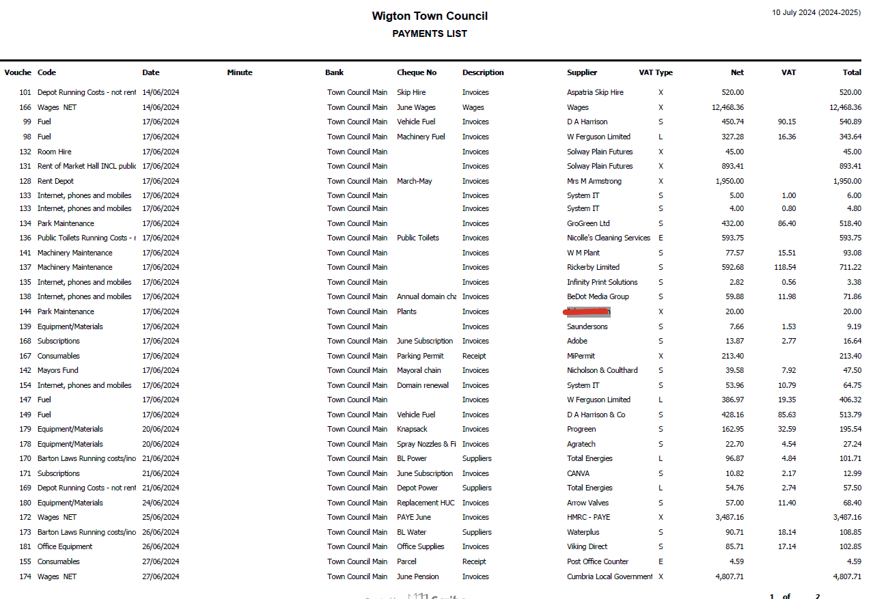
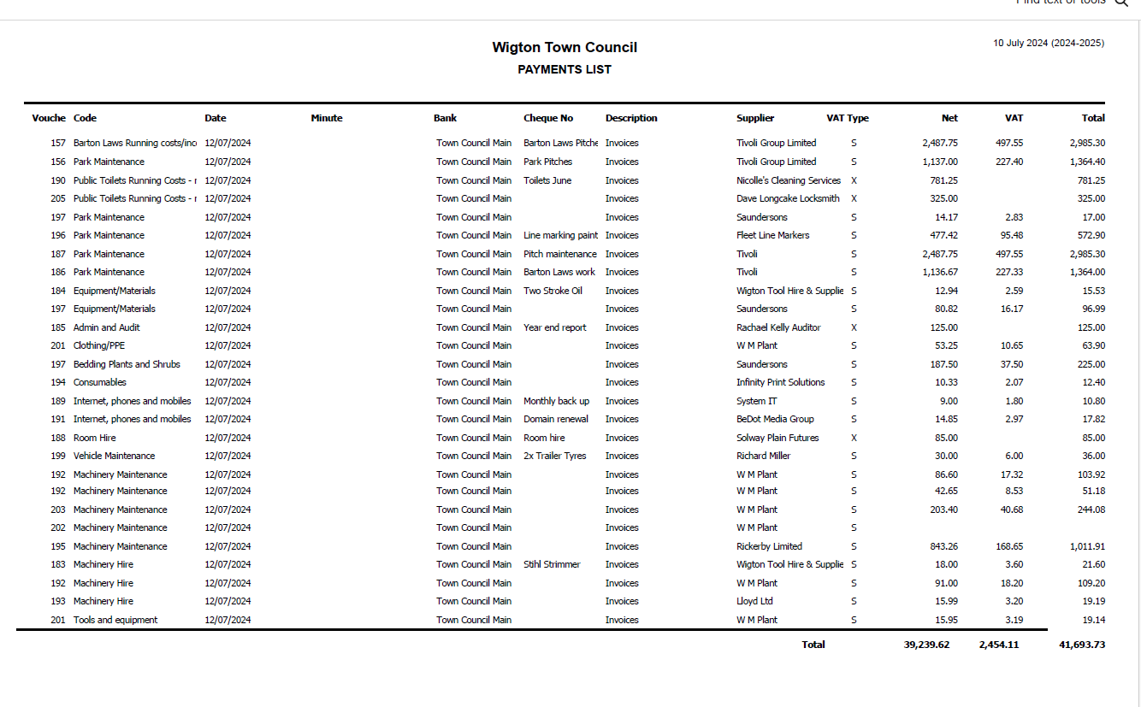

Extra Payments for WTC
Dave Longcake - £325 for public toilet door to be replaced.
WM Plant Hire - £83.04 for machinery maintenance
WM Plant Hire - £244.08 for machinery maintenance

Wigton Cemetery Payments

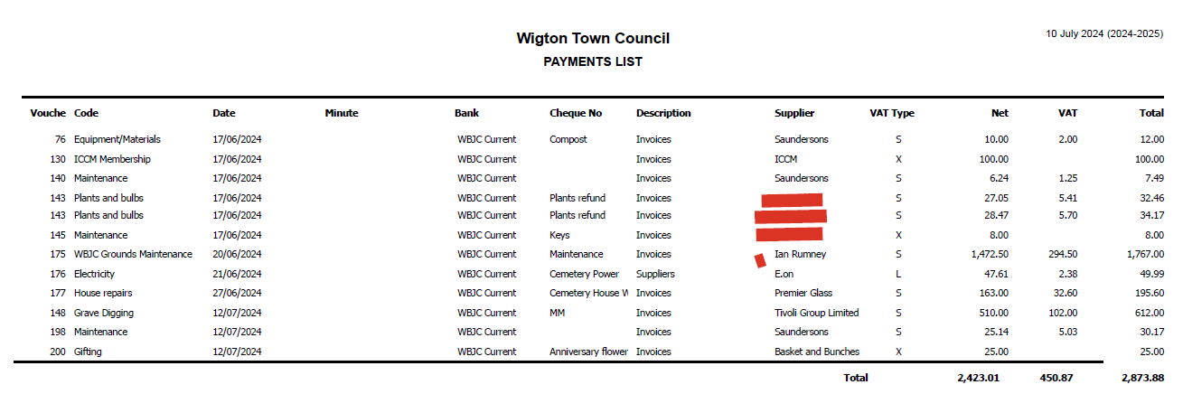

Extra Payments for WBJC
Baskets and Bunches - £25 for flowers

RESOLVED
Members approved all payments.

FC/46/2024 Grounds Maintenance Report – Provided by Grounds Maintenance

Grass cutting and weeding all our contract and council sites is our main priority at the moment with fortnightly cuts .
With the football season fast approaching I was very disappointed and angry with the state of the football pitches after the fair had left on carnival weekend . It will take a few manhours to try and get it into a playing surface again and will cost the council several hundred pounds to repair . The main issue was ruts left by the heavy wagons especially turning , next year the carnival cannot go on the field without supervision and there must be boards placed on the grass for the wagons to drive on. I just hope it hasn't damaged the structure of the soil and drainage.
All the town’s tubs have been planted, St Mary's and the Fountain look full of colour with the summer bedding, we haven't had to water much with all this rain but it needs to warm up. The park and Water Street beds look great with the all year round colour as well .
We are having issues with our small transit van at the moment and require a new van as this one has had its day unfortunately .
Speet Gill had been strimmed all around but needs some work done on the path throughout winter when we have more time .

FC/47/2024 Code of Conduct

Members were asked to review the current code of conduct and to suggest any amendments.

RESOLVED
Members voted unanimously to adopt the current version with no amendments.

FC/48/2024 Financial Regulations

In May 2024 NALC released their new model Financial Regulations for all councils of all sizes, it was then up to the council to develop their own set of financial regulations using this template. Any bold text indicated legal requirements that the council could not change.

The clerk/RFO used the template provided by NALC to develop a draft set of financial regulations that were relevant for Wigton Town Council, this draft copy was then shared with members of the WTC and the WBJC to review before the full council meeting on the 12th June 2024. At the meeting on the 12th June the financial regulations were discussed but it was decided that as so many members were absent, voting to adopt this version would wait until the July meeting. It was also agreed that the Clerk/RFO would meet with Cllr Ferriby the Chairman of the Finance Committee to scrutinise the draft copy and make amendments where necessary. After the Clerk/RFO met with Cllr Ferriby and made some amendments to the draft financial regulations, they were once again sent out to all members prior to the July meeting to review.

At this July meeting some members did not want to adopt the financial regulations as they were not an exact copy of the NALC version, it was explained that they needed to reflect what WTC needed and that it was advised by NALC to adapt the financial regulations, so they worked for each council.

It was decided that the vote to adopt the proposed current version of the financial regulations would be deferred until the September meeting until more members were present and had the opportunity to review the document.

It was reiterated by the clerk/RFO that NALC advised each council to make the model version fit for their council. It was also highlighted that none of the bold text had been amended therefore the draft version provided was fully

FC/49/2024 New Policies and Procedures

Cllr Hodson spoke to members regarding the importance of why policies and procedures must go through the Staffing, Policy and Development Committee before taking to full council to adopt. This would ensure that the policy or procedure is fit for purpose with approved members having an oversight of the policy or procedure.

It was discovered that many of the rules and regulations members suggested should be present in terms of references. Currently, not all committees have a set of terms of references so the clerk has been tasked with drafting a template that can be adapted for each committee.

RESOVLED
Clerk to create a template terms of reference form for committees to adapt.

FC/50/2024 Town Mayor’s Report

Cllr Hodson began her mayor’s report by paying her respects to the late Bill Lowther.

13th June
Had Coffee with a resident that was concerned with the Youth facilities and behaviour in the Town.
16th June
Confirmation Sunday. It was lovely to see 14 people getting Confirmed at St. Mary's Church by the Bishop of Penrith Rob Saner Haigh.
17th June
Visited Caldbeck & Heskett New Market Parish Council to see what issues they have and the similarities with Wigton.
18th June
Wigton Branch of the Royal British Legion held their meeting at St. Cuthberts.
19th June
Burial Committee held their AGM and Meeting after having a walk around the Cemetery.
22nd June
Carnival Day. A wonderful day for Wigton with the Sun Shining all day. A large Mayoral Party saw the best of the town and had a lovely day meeting all the entrants and residents of Wigton.
28th June
John Peel Theatre. A lovely night spent at our very own theatre.
29th June
Attended the Razzamatazz end of year show which supported several young members of Wigton from the age of 5 to 16.
5th July
Fun Day at St. Cuthberts School, this was rescheduled from an earlier date due to the Weather.
5th July
Open Mic. Night at John Peel Theatre.
6th July
Theatre on Saturday Morning for the Junior Showcase. Written by the young members and acted in front of Family and Friends.
6th July
Wigton Rugby Club were hosts to the Billy Goat Rally, a local Motorbike Club. All the campers were saying it was the best one yet and they would come back to Wigton anytime.

10th July
Attending my 4th consecutive Chrysalis AGM. It is a great privilege to attend as Mayor this year.

Some Events that I have been invited to have unfortunately had to be cancelled due to the weather. Rearrangements have been made for these events.

I hope that Everyone has a relaxing Summer Break and that we see as many of you as possible at our Party In The Park Event and look forward to welcoming you all back in September.

FC/51/2024 Clerk’s Report

The 2024/2025 budget had earmarked £25000 to purchase a new grounds maintenance van as the current vehicle was requiring a lot of maintenance work which was not a viable option anymore.

The Clerk/RFO recommended after undertaking the research into different options, to purchase an unregistered 2024 Maxus Deliver 9 high top van which allowed for more space. The Clerk/RFO secured a deal which included purchasing the vehicle for £21995 instead of £24995, 5 years breakdown cover, 5-year warranty and the first two services for free.

RESOLVED
Members unanimously voted to purchase the new vehicle.

Members were informed that the contract for the Christmas Lights had gone to Blachere Illuminations which will be a 3 year contract.

FC/52/2024 Member Reports

Cllr Ferriby – attended the Chrysalis AGM
Cllr Stapley – mentioned the state of some of the back alleys and attended the carnival.
Cllr McCarthy – attended the carnival and mentioned parking on the zig zags outside the infant school. It was mentioned that the Party in the Park would be soon and we have few members and volunteers so this could cause some issues.
Cllr Clark – asked whether planning applications were coming through to members or if it had changed since the Cumberland Council took over. One of the planning applications at Hope’s auction wouldn’t have come to the town council as it isn’t in the Wigton boundary. There were concerns over the proposed new development as it could impact on high street shops. It was also asked if all the minutes for committees were going on the website as some appeared to be missing, the is to double check.
Cllr Huntington – reported that a member of the public had signs and cones go missing through the day when he was at work at Stone raise, this was reported to the Police (Rural Crime).

FC/53/2024 Co-Option

One applicant was in attendance after being invited to attend this meeting. Members had previously been sent their application form. Cllr Hodson asked the candidate set questions and responses were received. The other members also had the opportunity to ask the candidate questions.

Afterwards the candidate was asked to leave which the members deliberated before a vote was taken.

RESOLVED
The vote was unanimous to co-opt Joan Greenup. The clerk advised she would be called into the office to sign her declaration and to complete the pecuniary interest form.

Meeting Closed – 8:56pm
Date of next meeting: Wednesday 11th September 2024

