A MEETING OF THE FULL COUNCIL WAS HELD ON
WEDNESDAY 11th SEPTEMBER 2024 AT 7.00PM
PRESENT –
Councillor Sandra Hodson (Chairman and Mayor)
Councillor Chris Stapley
Councillor Monique Speksnyder
Councillor Shane McCarthy
Councillor Mary Huntington
Councillor David Ferriby
Councillor John Crouch
Councillor Mary Clark
Councillor Anne Jackson
Councillor Chris Scott

Clerk: Emma Ireton

FC/54/2024 TO RECEIVE APOLOGIES & REASONS FOR ABSENCE
Councillor John Hamblin
Councillor Joan Greenup

FC/55/2024 MINUTES FROM PREVIOUS MEETING
To agree to the Full Council minutes of the 10th July 2024 – an amendment was requested to include Cllr Clark.

FC/56/2024 DECLARATIONS OF INTERESTS, MEMBERS AND OFFICERS TO GIVE NOTICE OF INTERESTS ON ITEMS ON THE AGENDA

Cllr Hodson declared an interest in agenda item 7.1 in relation to the payment to the Wigton Town Council depot.

FC/57/2024 EXCLUSIONS OF PRESS AND PUBLIC

NONE

FC/58/2024 PUBLIC PARTICIPATION

To receive any representations from members of the public – Members of the public are invited to speak for a maximum of 5 minutes each. The maximum total time for public participation will be 10 minutes. At the close of this item, members of the public will no longer be permitted to address the Council Members unless invited to do so by the Chairman.

Item 5 was swapped with item 6 at the request of the chairman

6. Allotment Prizes

Cllr Hamblin prepared a statement for the chairman to read out in his absence which congratulated the winners of the allotment inspections for 2024 as well as mentioning the difficulties that allotment holders faced due to adverse weather conditions.

Best Plot - awarded to Mr & Mrs Graham (not in attendance)
Most improved plot - awarded to Carron Allison (not in attendance)
Chairman’s Choice – awarded to Elizabeth Browne who was in attendance to receive her certificate and prize of £25.

5.1 Public Participation

A member of the public was in attendance but made no request to speak.

5.2 Cumberland Authority Report

Cllr Elaine Lynch was in attendance having lots to report.

There had been some comments made regarding the flooding at Burnfoot, so this has been noticed and the Cumberland Council are working on a solution. They are also speaking with CCL to ensure they are looking at the problem. A drone also goes up every week to check.

It was reported that there had been some issues with planning in relation to Laurel Terrace, this is also being looked in to.

A member of the public had reported potential water pollution at Cuddy Lonning so tests have been carried out.

Borderlands had their first meeting in some time, the chairman voted in was Sandra Keaveney from NADT and the vice chairman was Cllr Sandra Hodson, Sandra will be able to report information back to full council members

On the 7th and 8th November, the bollards at the fountain will be installed. They will be removable with a key being held at the Town Council office, a key will also be held for the bollards being placed at Lowmoor Road/Tenters.

A member of the public had been in touch to discuss electric vehicle parking places as there are none in Wigton. There is money available through the Cumberland Council so this is being looked at.

Members were informed that the town was due for a deep clean, which should take place in October. It was suggested that the cleaning schedule is shared with the town council office so other cleaning can be planned.

Wigton Baths have been receiving support from council officers, providing advice on funding as they are in need of a cover for the pool.
There community panel network event was successful as lots of groups were present to discuss health which is a big issue with some groups including farmers. Different agencies are getting involved to look at health and mental health including the Police, CAB and Andy’s Mans Club. It was also noted the Andy’s Mans Club would be opening in Wigton on the 4th November and they will be present at the next meeting to talk to members about what they do.

In relation to Highways it was reported that there is going to be an improvement in bus services with plans to increase routes to Silloth and reinstate old routes such as Silloth to Maryport. It was also noted that the 300 bus would run every 30 minutes. There are also plans to improve the waiting facilities, including the Wigton stop next to the Throstle’s Nest. The older buses are also to be reduced and electric buses will be investigated although only in Carlisle to start with. There are no toilets at the Carlisle bus station so this is also being looked at.

The crossing survey has been completed but the results have not yet been revealed.

Residents from George St have made complaints regarding non residents parking on an already tight and narrow street, it is believe people are using George St to park all day when they work in the town centre.

The 20 MPH sign will be coming soon to Southend and Lowmoor Road with lights flashing at a certain time.

Lastly, at an event at Carleton Hall in Penrith, the Police summarised their recent inspection. They did will in all areas and did not receive any complaints about 101 or 999 as calls were answered within seconds.

FC/59/2024 Finance Matters

7.1 To receive and authorise Payments and Bank Reconciliation for August 2024

Members received the payment lists prior to the meeting and extra invoices were read out to members for them to approve.

Wigton Town Council Payments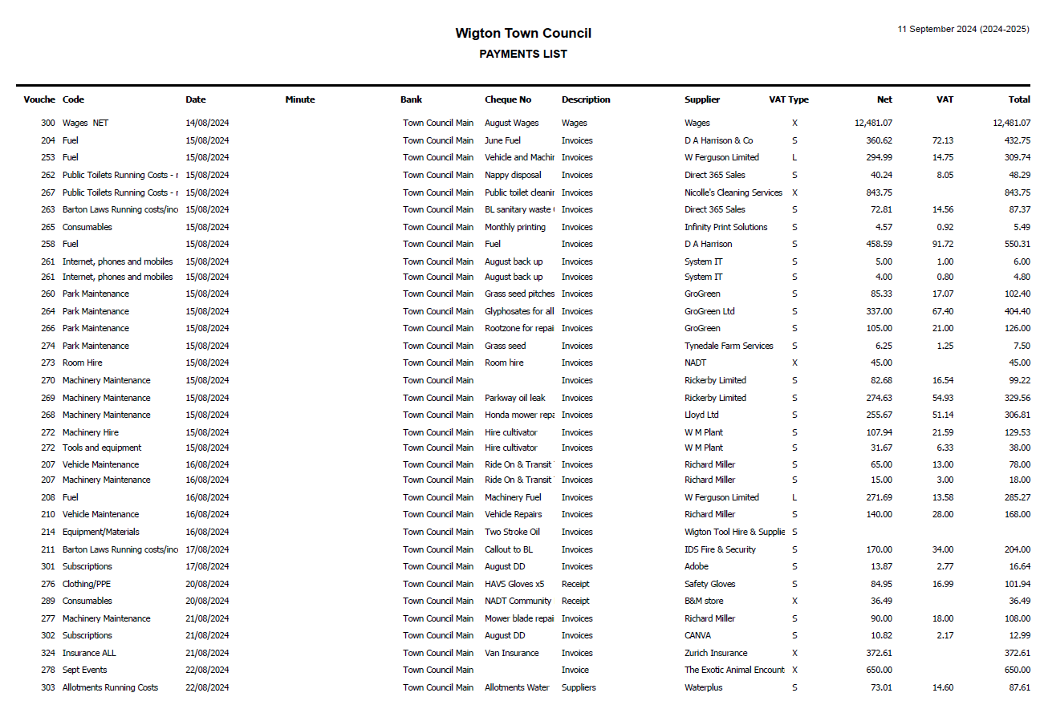

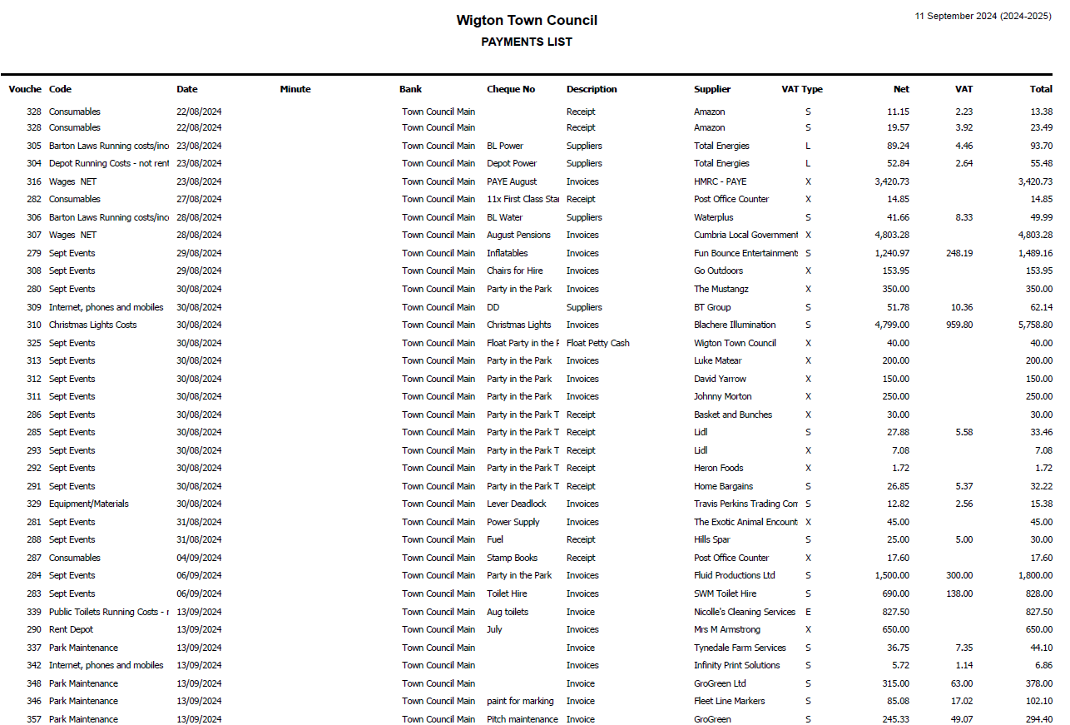

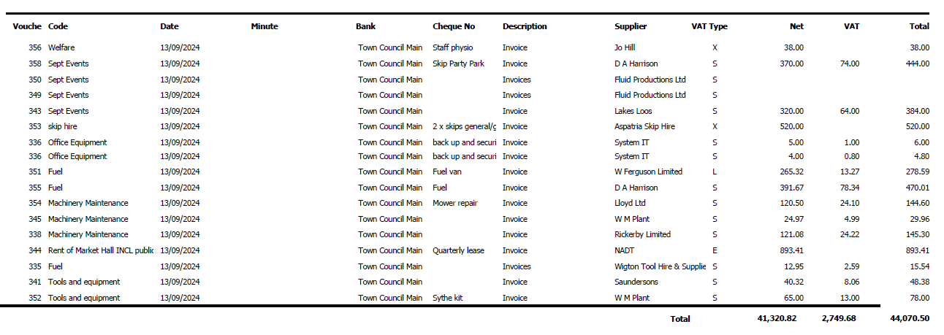

Wigton Cemetery Payments

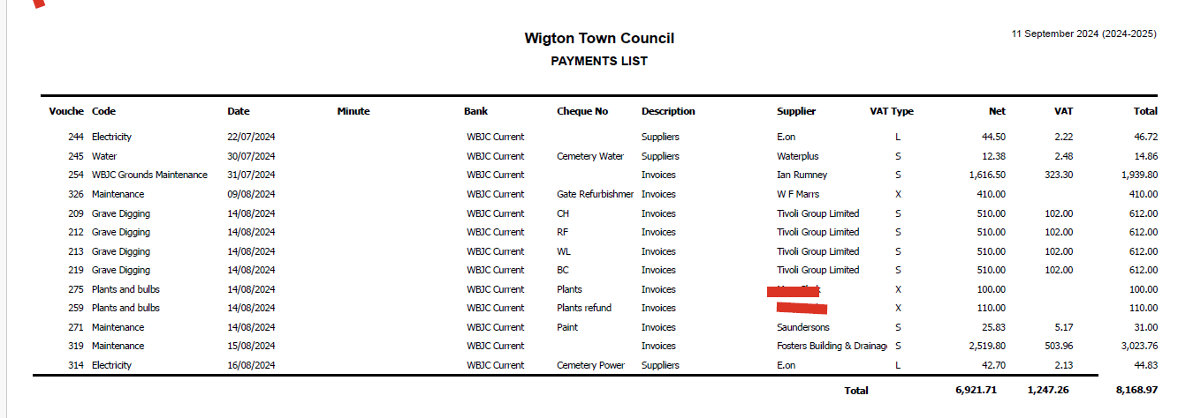

RESOLVED
Members approved all payments.

7.2 To provide an update on the external audit

Members were informed that there had still been no news on the external audit.

  - 2025/2026 Budget

Members were asked if they could suggest any project that may need to be budgeted for in the 2025/2026 budget. The toilets at Wigton Park were mentioned as well as the drainage issues at both Barton Laws and the Park. Members were asked to get in touch with the clerk if they wanted to add a specific item to the budget to be considered.

Cllr Scott at this point raised that the Mayor’s Fund was not substantial enough to cover all aspects of the role. It was noted that clothing may be needed when the Mayor is attending important events along with charity donations, the cost of fuel, purchasing tickets to events and many other examples. It was proposed by Cllr Scott that the budget should be increased from £300 to £1500 with immediate effect. This was seconded by Cllr McCarthy.
RESOLVED
Members agreed that the finance committee should look at the request.

  - Town CCTV renewal

The clerk informed members that the town CCTV was due with the annual payment being £6005.52 + VAT. The clerk reminded members that Bedroq must be used to maintain the town CCTV as they have been contracted by the Police so alternative providers cannot be used.

RESOLVED
Members UNANIMOUSLY agreed to make the annual payment.

FC/60/2024 Grounds Maintenance Report – Provided by Grounds Maintenance

July and August have been extremely busy months, as well as all our fortnightly cuts we had a long list of jobs to do in all of the schools .
Grass cutting has been a problem of late with the wet summer we have had. Consequently, we have had to cut areas with hand mowers where normally we would use a ride on mower with the land been too wet but we are catching up now it has dried up a little. Plus, for a while we were without our Honda rotary mowers and had to borrow a smaller rotary mower off Lloyds while the other two mowers were being repaired due to wear and tear. These mowers are used a lot, so it was unfortunate that both mowers broke down at the same time. It is my recommendation that we purchase another mulching mower to alleviate the pressure off the other two mowers.

The football season is now underway so hopefully the pitches will stand up to all the play, especially the main pitch at Barton laws due to all the heavy traffic that went over it (the fair). A lot of work went into trying to correct the problem, I had to put in 4 ton of root zone and seed, this took many man hours. I'm just hoping that it hasn't caused any underground damage to the drainage system.

I have asked Wigton Harriers to find some funding to gain some stronger and longer slit tines for our sisis multislit machine. Hopefully, this is successful as we need these to help with the pitch maintenance. Also, we need to drain the 9 v 9 pitch at the park as it is soft especially down the left hand side and this would help the party in the park in the future. It was a great success again ( thanks especially goes to Emma, Sophie and Ben). The drainage work would have to wait till after the season has finished May/June 2025.

We have our new van now which is a great help and a lot better than the old one.
As I said in my report earlier July and August have been busy months with all the school work, all the work as in erecting football and rugby posts marking out pitches, remarking the tarmac car park and tarmac sports areas (junior school), cutting shrub beds , hedges and weed spraying was completed.

There is one job that we haven't had to do much this summer is watering the flower tubs in the town centre which have looked nice again this year with the all year round colour in the Water Street, the beds are coming along nicely, as are the park beds.

FC/61/2024 Complaints Procedure

Members were asked to review the current complaint procedure and to suggest any amendments.

RESOLVED
Members voted unanimously to adopt the current version with no amendments.

FC/62/2024 Financial Regulations

As mentioned in previous meetings and minutes, In May 2024 NALC released their new model Financial Regulations for all councils of all sizes, it was then up to the council to develop their own set of financial regulations using this template. Any bold text indicated legal requirements that the council could not change.

The clerk/RFO used the template provided by NALC to develop a draft set of financial regulations that were relevant for Wigton Town Council, this draft copy was then shared with members of the WTC and the WBJC to review before the full council meetings on the 12th June 2024, 10th July 2024 and 11th September 2024.

There are differing reasons for not signing off the financial regulations each month and this includes members not reading them, not enough members present to discuss and adopt them and members who believe that it is wrong to make changes to the NALC version as they were a model version.

Members were reminded by the clerk that the NALC version was intended to be amended to suit each council and it is not a failure for the RFO to recommend different figures.

It was discussed how to move forward with many members asking for a justification of changes which the clerk/RFO was happy to provide.

RESOVLED
Defer to the October meeting where members will receive a rationale for changes.

FC/63/2024 Cemetery Update – Cllr Clark

The weather was noted as being an issue as the rain has made it difficult to undertake a lot of the ground’s maintenance. Grave digging is the biggest issues as there are still complaints being made regarding graves sinking. There have been meetings with WBJC members and representatives from the Cumberland Council who are offering advice. The current grounds maintenance contractor has been tasked with topping graves up as this is quicker than waiting for the grave digging contractor to return. This is an important issue and one that the WBJC are still trying to resolve.

The chairman gave a member of the public the approval to speak at this point.

The member of the public spoke about his experience and knowledge in relation to grave digging as he worked in the same industry. It was clear he was disappointed with how some graves have been left as it is upsetting for families. The ICCM and their policies were also referred as well as the fact that he has visited many cemeteries who don’t repeatedly see these issues.

Cumberland Cllr Elaine Lynch also agreed and stated there needs to be a change.

RESOVLED
The WBJC will liaise with Cllr Lynch and the Cumberland Council representative to try and find a resolution..

FC/64/2024 Planning

The clerk advised members that planning would appear on future agendas to allow members to raise any queries or for the clerk to provide any updates. It was noted that all decisions and applications will not be read out, just reviewed where appropriate.

At this meeting Strawberry Meadows was discussed, there had been an update which noted there would be no changes to the types of houses.

The RBL building in Wigton was also discussed with members asking that the historical plaque be returned to the Town Council so it can be moved somewhere more appropriate. Cllr Lynch agreed to speak to the planning department on our behalf.

FC/65/2024 Mayor’s Report

Visited a 100 year old resident for her birthday.
Will be attending her civic service on 22nd September.
Attended Aspatria’s Civic Service

FC/66/2024 Clerk’s Report

Reported back on the Party in the Park which was another successful event. It was highlighted that more members are required in the future as it was difficult to set up and close. Several thanks were given to those that supported the event and helped.

It was reported that Wigton Baths trust have asked for their building to be included in the heritage leaflet. Cllr Ferriby brought up the leaflets he has mentioned previously, suggesting this information could also be on the business directory and the leisure activities.

An update was given regarding the apprentice assistant Town Clerk, she is coming to the end of her apprenticeship, completing 6 months early. Now she will be trained to undertake the role of the RFO to ensure there is some succession planning.

It was also reported that a new charity had been in touch to ask about hiring Barton Laws on a long-term basis. The charity will help the older generation giving them somewhere to go to socialise, do light exercise, do crafts and watch tv. Members asked for more information before a decision could be made.

FC/67/2024 Member Reports

Cllr Speksnyder – Borderlands meeting and Party in the Park
Cllr Ferriby – Party in the Park
Cllr Jackson - Party in the Park and Aspatria’s Civic Service. Also noted the nettles around the benches in the town.
Cllr Huntington – WBJC meeting and asked about the St Mary gates, the clerk to investigate. The rose garden at St Mary’s was also reported as being in a dreadful state so the grounds team will take a look.
Cllr Stapley – asked about installing solar lights in Wigton Park
Cllr Crouch – Party in the Park
Cllr McCarthy – Party in the Park and collected donations/prizes.
Cllr Scott – Party in the Park

Meeting Closed – 9:04pm

Date of next meeting: Wednesday 9th October 2024

