A MEETING OF THE FULL COUNCIL WAS HELD ON
WEDNESDAY 13th NOVEMBER AT 7.00PM
PRESENT –
Councillor Sandra Hodson (Chairman and Mayor)
Councillor Chris Stapley
Councillor Shane McCarthy
Councillor Mary Huntington
Councillor Mary Clark
Councillor Anne Jackson
Councillor Chris Scott
Councillor Joan Greenup
Councillor Ferriby

Clerk: Emma Ireton

FC/79/2024 TO RECEIVE APOLOGIES & REASONS FOR ABSENCE
Councillor John Hamblin
Councillor John Crouch
Councillor Monique Speksnyder

FC/80/2024 MINUTES FROM PREVIOUS MEETING

To agree to the amended Full Council minutes of the 11th September 2024 -Approved
To agree to the Full Council minutes of the 9th October 2024 - Approved

FC/81/2024 DECLARATIONS OF INTERESTS, MEMBERS AND OFFICERS TO GIVE NOTICE OF INTERESTS ON ITEMS ON THE AGENDA

NONE

FC/82/2024 EXCLUSIONS OF PRESS AND PUBLIC

Agenda item 9 was moved to a closed session due to confidentiality.

FC/83/2024 PUBLIC PARTICIPATION

To receive any representations from members of the public – Members of the public are invited to speak for a maximum of 5 minutes each. The maximum total time for public participation will be 10 minutes. At the close of this item, members of the public will no longer be permitted to address the Council Members unless invited to do so by the Chairman.

5.1 Public Participation

A member of the public was present to observe the full council meeting and will also shadow the chairman when undertaking community engagement.

5.2 Cumberland Authority Report

No representative present although members had a few questions to be passed to Cllr Elaine Lynch.

Why are the bollards not installed yet?

Could planning investigate why Harrison’s planning request had been refused, was it because they wanted to install solar panels? If so, other High Street properties also had solar panels fitted.

FC/84/2024 Finance Matters

6.1 To receive and authorise Payments and Bank Reconciliation for October 2024

Members received the payment lists prior to the meeting and extra invoices were read out to members for them to approve.

RESOLVED
Payments for October 2024 were UNANIMOUSLY approved.

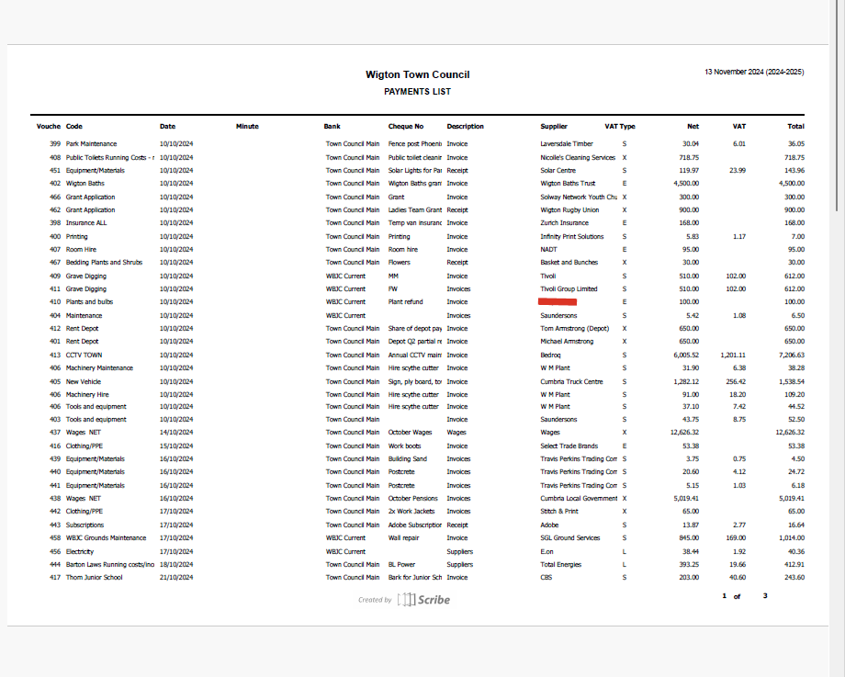
Wigton Town Council and Wigton Cemetery Payments

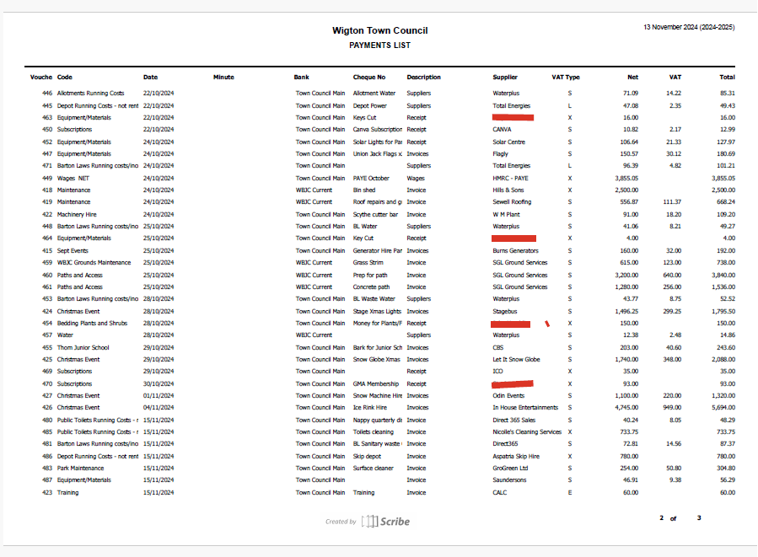

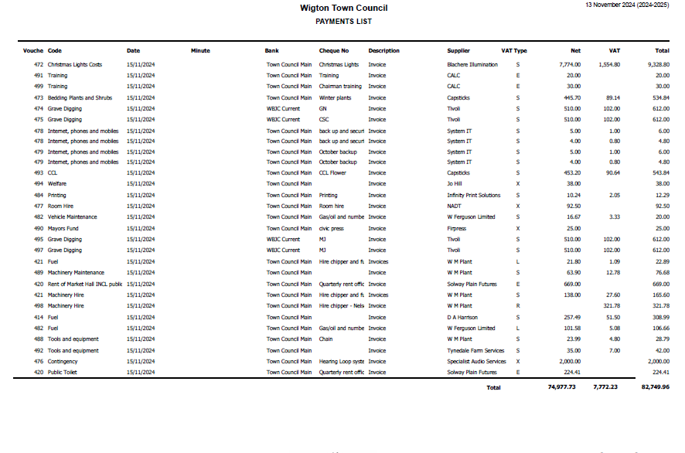

6.2 To receive an update regarding the Local Government Pay Agreement 2024

The clerk/RFO provided members with an update regarding the Local Government Pay award which provides an increase of £1290 for each employee up to SCP 43, all of WTC employees are under SCP 43 so will all receive backdated pay from 1st April 2024.

6.3 To receive a quote for repairing the Mushroom in Phoenix Park and decide on next steps

A local fabricator/engineer Flash Fabrication submitted an assessment of the mushroom along with a quote to repair. The mushroom is currently in a poor state with sharp bits of metal exposed which could be a H&S issue. There is also a hole under the metal floor plate which could be a trip hazard.

To repair the cost was £7950 which was to cut and patch steel sections, prepare the surface for repair and painting and the fabrication and installation of seating and benches. To go ahead with the project an upfront payment of 25% is required to purchase materials.

North Stonework and Landscaping provided a quote of approximately £2500 to prepare the ground and concrete a new base but this depends on the size of the hole that requires filling, so the amount of concrete is unknown.

RESOLVED

Members voted UNANIMOUSLY for the work to be undertaken.

6.4 To receive an update regarding other projects.

Members were presented with a quote from Flash Fabrications to repair and refurbish the Dalton Shelter. The total quote was £11455 and this was to:

Remove All Benches and Partitions: Dismantle and dispose of existing benches and partitions.
· Strip, Patch, and Repair Concrete Balustrades: Remove damaged concrete and repair balustrades.
· Pressure Wash and Repair Slate Roof: Clean the slate roof and replace or repair damaged slates.
· Repair and Replace Missing Gutters: Inspect and replace damaged or missing gutters.
· Fabricate, Design, and Fit New Seating Facilities: Create and install new seating based on design specifications.
· Prep and Paint New Seating Facilities: Prepare surfaces and apply paint to new seating.
· Manufacture New Unique Sheet Metal Designs for Central Column: Design and install custom sheet metal features for the central column.
· 12-Month Care Programme: Develop and provide guidelines for ongoing maintenance.
Members discussed the quote and there were some questions asked about the type of the steel as galvanised or stainless steel would be more long lasting.
North Stonework and Landscaping quoted £3200 to remove the current concrete base and pour a new base with sloping sides which will allow for better access.
RESOLVED
Members asked to double check the steel used and if mild steel is being used then to get some confirmation that this will be prepared, painted and long lasting. Members UNANIMOUSLY approved this work to be undertaken once the questions regarding the steel were answered.
The park toilets were also discussed, and members were provided with one quote that had returned out of two contractors that has been to visit the site and measure up. The quote was from Border Plumbing:
New windows - £2400
Repairing the roof, installing new toilets and urinals, new lighting, water heater in the ceiling, new fuse box, new flooring, hand dryers, plastic sheet panels in toilets, skimmed walls and painted. All fixtures would be hidden and vandal proof. Total quote - £35000
A third quote was also gained from a company that make bespoke toilet cabins cladded in wood, the quote for this was £25880 EXCL VAT. This option would still require services to be installed.
No decision was made as a second quote was still required.
Financial regulations also state that any job over £30000 requires the tender process to be followed.
£35000 has been budgeted in 2025/2026.

FC/85/2024 Allotment Perimeter

Cllr Hamblin was absent from the meeting but the clerk spoke in his place. A complaint had been received by an allotment holder who had requested the town council’s help in replacing their gate, but their request was denied by the POA committee. This decision was appealed so was brought to the full council meeting for consideration. The appeal is part of a larger issue which is what is the allotment perimeter? Members discussed that they had already decided at previous meetings that the perimeter did not include those allotments that ran down the bridleway. It was decided that more information would be required before this could be looked at again and part of the information would be the Allotment Association’s view on this.

In the meantime, members voted on whether the gate belonging to the allotment holder above should be replaced by the town council.

Members voted but the motion was rejected.

FC/86/2024 Grounds Report

School work
Over the half term we were extremely busy in the schools picking up leaves and cutting grass, especially the Nelson Thomlinson as they wanted a large area of shrubs cut down to four feet with the brash shredded back onto the shrub beds. The tarmac netball courts were also sprayed for moss and all the sports pitches were marked out again. In the Thomlinson Junior School they wanted a bark base put under two tyre swings that they have hanging from trees plus all the grass was cut and leaves tidied up on the front car park.
All winter bedding has been planted up as well as the tubs around St Mary's, Water Street and the Junior School areas. We have left the fountain summer plants up for now as there is still a bit of colour in them with all this mild weather we have been having.

We have had to cut all our sites again with all the mild weather we have been having including Dalston Parish and church. Hopefully that is it as the Parkway mower is going in for its annual service, this is never cheap, but this is an essential piece of machinery and is needed to be in top condition for the coming season. It is getting older every year and they are not cheap to buy now approx. £45,000, a plan must be put in place so when the time comes it can be replaced with a new one.

All the football pitches at the park and Barton Laws have been busy every weekend so we are having to put a lot of hours and work into the pitches to keep them in good playable condition with regular spiking, pitch grooming and marking out.

Lighting has been installed down at Wigton Park with solar panel lighting placed on the trees. Some of them don’t always work because the branches block the light but I will keep moving them.

St. Marys Church - We have been doing quite a bit of work lately in the grounds with the roses being pruned at the rear we just need to put some mulch on the beds. The sandstone flags at the front and down the sides have been cleaned with hypochlorite. All tubs and front beds have been planted up with winter bedding, shrubs shaped and clipped back, grass cut and leaves picked up.

FC/87/2024 Town Mayor’s Report

See attached.

FC/88/2024 Clerk’s Report

HSE visited the depot to carry out an inspection of the pesticides used; the inspection went well with one verbal recommendation which was to record the MAPP numbers on the pesticide records. The COSHH/pesticide cabinet was not HSE approved as it was old, so a new one needs to be purchased which is going to be around £500 - £1000 to replace. There are also some pesticides that were out of date and two that were unauthorised, so we need to arrange for these to be disposed of.

The hearing loop and microphone system has been fitted and is now ready to use.

It was reported that the car park on the 30th November would be free from 7am to 7pm and we have also been allowed to take half of the car park so we can fit more entertainment on such as the reindeers. The Cumberland Council are reviewing their policies so this may be the last time the car park is free.

The clerk also asked for volunteers to help with the lights switch on.

It was suggested that we write to the three factories to ask if any of their employees would like to join the town council as a councillor.

FC/89 /2024 Member Reports

Cllr Greenup – mentioned dirty street and cigarette butts outside the pubs.
Cllr Jackson – swept and weeded Memorial Garden. Received a complaint regarding factory fence which is the Highways which needs reported. Also, overgrown path at Highmoor. Judged Halloween pumpkins at the Food Pantry and attended Remembrance services. Visited a Silloth Town Council’s Accessibility committee meeting
Cllr Huntington – Remembrance Service, asked about the gate at St Mary’s. Also mentioned the complaint regarding a wreath being moved which has since been returned. The names on the memorial garden are also faded.
Cllr Stapley – Thanked grounds staff for the lights at the park and Remembrance service
Cllr Clark – Inauguration service and remembrance service.
Cllr McCarthy – Remembrance service
Cllr Scott – Inauguration service, remembrance service and selling poppies. A football team contacted him to say about the dog mess on the pitches.
Cllr Ferriby – thanked Sandra for the poppies around time, mentioned that the budget is almost complete and will be signed off the day before full council when the committee meets again. Also carol service on 15th December at 3pm.

Meeting Closed – 9:11pm

Date of next meeting: Wednesday 11th December 2024

