A MEETING OF THE FULL COUNCIL WAS HELD ON
WEDNESDAY 9th OCTOBER 2024 AT 7.00PM
PRESENT –
Councillor Sandra Hodson (Chairman and Mayor)
Councillor Chris Stapley
Councillor Shane McCarthy
Councillor Mary Huntington
Councillor Mary Clark
Councillor Anne Jackson
Councillor Chris Scott
Councillor Joan Greenup

Clerk: Emma Ireton

FC/68/2024 TO RECEIVE APOLOGIES & REASONS FOR ABSENCE
Councillor David Ferriby
Councillor John Crouch
Councillor Monique Speksnyder

FC/69/2024 MINUTES FROM PREVIOUS MEETING
To agree to the Full Council minutes of the 10th July 2024 – APPROVED
To agree to the Full Council minutes of the 11th September 2024 – NOT APPROVED

After the 10th July 2024 minutes were approved and before voting to approve the 11th September minutes one member highlighted that they considered the minutes for September being incorrect due to the wording used. It was raised that the word ‘wrong’ was used in relation to describe the situation around the financial regulations. The clerk had written that the financial regulations had not been approved as they were deemed to be wrong. Two members agreed that this word was incorrect and that it should be written that the financial regulations had not been approved as the draft version included amendments that the two members described as being unnecessary. The clerk reminded members that minutes were her record of what was said at the meeting, and it was implied that the financial regulations were not approved as some members believed them to be wrong or incorrect. The clerk reminded members that meetings were recorded so she and the chairman would check the wording and feedback at the next meeting and therefore defer approving the September minutes.

*When the clerk and chairman checked the minutes after the meeting it was found that the wording that was disputed belonged to the July 2024 minutes which were approved at the September meeting.

FC/70/2024 DECLARATIONS OF INTERESTS, MEMBERS AND OFFICERS TO GIVE NOTICE OF INTERESTS ON ITEMS ON THE AGENDA

Cllr Hodson declared an interest in agenda item 6.1 in relation to the Wigton Town Council grounds maintenance depot.

FC/71/2024 EXCLUSIONS OF PRESS AND PUBLIC

NONE

FC/72/2024 PUBLIC PARTICIPATION

To receive any representations from members of the public – Members of the public are invited to speak for a maximum of 5 minutes each. The maximum total time for public participation will be 10 minutes. At the close of this item, members of the public will no longer be permitted to address the Council Members unless invited to do so by the Chairman.

5.1 Public Participation

NONE

5.2 Cumberland Authority Report

NONE

FC/73/2024 Finance Matters

6.1 To receive and authorise Payments and Bank Reconciliation for September 2024

Members received the payment lists prior to the meeting and extra invoices were read out to members for them to approve.

Before approving the payment list one member queried payment 392 and asked why there was no NET amount and only VAT and a TOTAL of £900. The clerk explained it was an error when inputting the item into the accounting software and the NET amount should have been £750 so it will be updated.

It was also queried why there was a payment to Bron Ja, a ladies clothing store in Wigton. It was explained that the purchase of £135 was to purchase a formal dress for the Mayor as she was expected to attend several formal functions, therefore required suitable attire. Members debated whether this was an appropriate use of money. Within the budget there is a Mayor’s f und, so it was explained that this purchase came from the budget and was within spending limitations. It was also noted that the Mayor’s budget had increased from £300 to £1500 to allow every Mayor to be able to carry out their civic duties. Cllr Scott the previous Mayor explained that during his tenure, he spent almost £2000 of his own money attending events linked to his Mayorship and urged other members to trust that a larger budget was required. The clerk/RFO also assured members that requests to make purchases do need to be cleared through the office so the entire budget could not be spent on inappropriate items.

It was suggested that in order to ensure the budget of £1500 be spent wisely, there should be a policy attached to the Mayor’s budget which will be reviewed by the Policy, Staffing and Development Committee.

RESOLVED
Payments for September 2024 were UNANIMOUSLY approved.

Wigton Town Council Payments

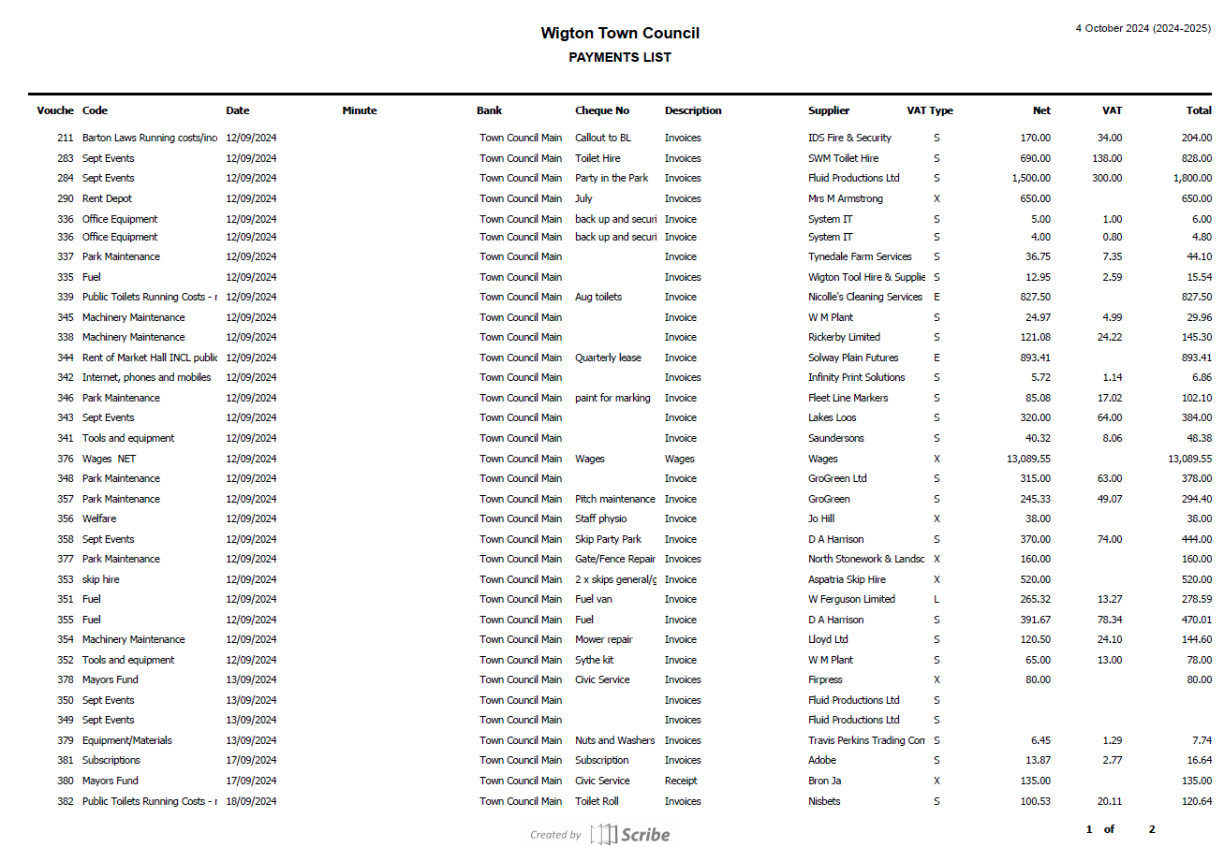

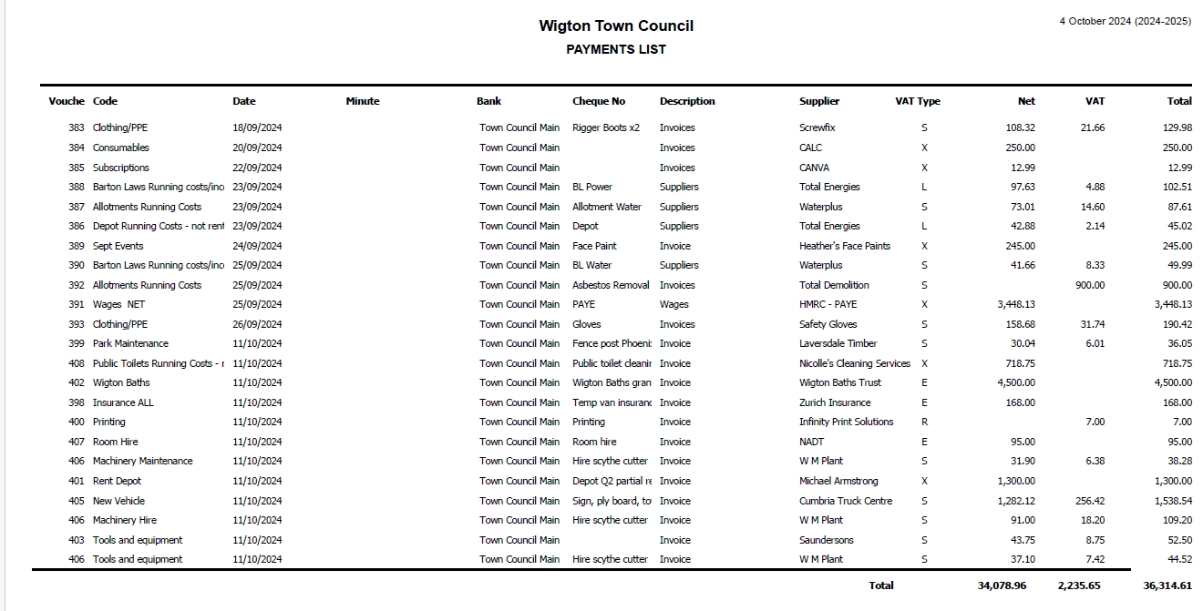

Wigton Cemetery Payments

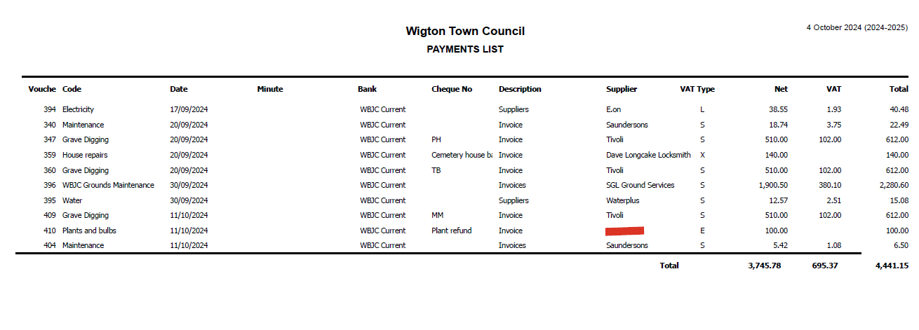

6.2 To discuss the contents of the draft financial regulations and vote to adopt.

Before the meeting the clerk/RFO sent out a comparison of the NALC version of the financial regulations and the draft Wigton Town Council version so that the differences could be discussed.

Before reviewing the comparison, a few members suggested that as they had the documents in advance it should go straight to a vote to adopt.

RESOLVED

Members voted to adopt the Wigton Town Council’s adapted financial regulations.
6 voted in favour.
1 abstained.
- voted no.

FC/74/2024 Grounds Maintenance Report

Bowling Green
The end of season work has been completed on the green which included scarifying three times, cutting, hollow coring picking up the cores then seeding and fertiliser put on .

Nelson Thomlinson
Nelson wanted some additional work done on the school lodge garden. Work included cleaning out a lot of overgrown shrubbery and trees and the brash will be shredded and put back on the school shrub beds. Nelson have complemented our work as the lads sent did such a good job. We have also been doing the seasonal work on their sports pitches so spiking and using the pitch groomer to keep them in good condition.

All our sites are having their last cuts in the next couple of weeks, I just hope we don't have a mild winter like last year where the grass grew all year long.

Dalston
We have been cutting down some of their wild flower areas and disposing of the clippings and also giving their parish and church their last cuts.

Barton laws/park pitches
The season is in full flow now with a very busy schedule we are keeping on top of the pitches keeping them in good condition with all the play on them which is spiking, pitch grooming and topping the grass plus marking out.

Innovia/Futamura
The full site has been sprayed for weeds and this will be the last application until next year.

CCL work
They are wanting some extra work done on their shrub beds which includes taking out old shrubs and replanting with new shrubs , membraned and mulched in the coming month.

Shrub beds and hedging
We will start work on cutting and tidying up shrub beds and hedging on all site with Dalston wanting a couple of hedges knocked down in height over the next couple of months.

Summer bedding
The town tubs and bedding have looked really good this year but in the next couple of weeks they will be taken out and replaced with winter plants.

FC/75/2024 Cemetery Report – Cllr Mary Clark

Luke Leathers, the Healthy Places Service Manager from the Cumberland Council who oversees grave digging attended the latest WBJC meeting where he provided some suggestions around improvements. The WBJC will also try and meet with the person responsible for the Tivoli team who dig graves at Wigton to see what improvements can be made to reduce graves sinking.

So far this year there has been 15 funerals, at this point last year there had been 22.

The entrance work is scheduled for the 23rd October but this is weather dependent.

It was reported that there were ongoing issues with some visitors allowing their dogs to go to the toilet on the Cenotaph and other special areas so the clerk had been asked to put a post on social media reminding visitors to keep dogs on leads and to prevent dogs from being near the Cenotaph.

A new path has been put down near the side entrance which has tidied the area up.

Members were informed that the hedge around the house was dead, so they were waiting for a quote to replace it.

Hopefully the Friends of the Cemetery would be set up soon.

FC/76/2024 Town Mayor’s Report

See attached.

FC/77/2024 Clerk’s Report

Members were advised that the ownership of the ground’s maintenance depot had now changed hands with the new owners being Mike and Tom Armstrong. The rent has not increased since Wigton Town council had been renting it so there was a planned increase of £2500 PA from April 2025 taking the annual rent to £10000 PA.

The Montini Circus who at short notice asked to use Barton Laws have not paid their invoice, they also damaged one of the gate posts which they had been billed for which also has not been paid. It was agreed a letter would be sent to them with a discounted invoice to try and recover some of the funds.

The clerk provided members with a quote from Specialist Audio Services to install a hearing loop in the Solway room at the Market Hall where all Full Council meetings are held. Members were advise that the necessary research had been undertaken and this company offered the best solution and came recommended.

Quote 1 – Hearing loop system £1500
Quote 2 - Hearing loop system PLUS speakers and microphone system £2000

RESOLVED
Members unanimously voted to approve Quote 2 for £2000 as this would benefit all attendees.

The clerk shared a proposal of the finance committee which was to form a subcommittee to assist with large projects the town council have, the idea was to help speed up decision making.

FC/78/2024 Member Reports

Cllr Jackson – Mayor’s Civic Service and the Licensing Service for Reverend Richard Corrie. Also requested the office contacts the Lion and the Lamb to report cigarette ends on the street.
Cllr Huntington –.WBJC meeting and the Licensing Service for Reverend Richard Corrie
Cllr Stapley – A reminder about lights in Wigton Park
Cllr Clark – Suggested a system may be required to pay for births and deaths etc.
Cllr Hamblin – Reminded members about Cumbria in Bloom on the 15th
Cllr McCarthy – Attended the Mayor’s Civic Service
Cllr Scott - Mayor’s Civic Service and the Licensing Service for Reverend Richard Corrie. Also asked about having the dog warden in Wigton because of the dog mess.

Meeting Closed – 9:14pm

Date of next meeting: Wednesday 13th November 2024

