A MEETING OF THE FULL COUNCIL WAS HELD ON
WEDNESDAY 11th DECEMBER AT 7.00PM
PRESENT –
Councillor Sandra Hodson (Chairman and Mayor)
Councillor Chris Stapley
Councillor Shane McCarthy
Councillor Mary Huntington
Councillor Mary Clark
Councillor Anne Jackson
Councillor Chris Scott
Councillor Joan Greenup
Councillor David Ferriby
Councillor John Hamblin
Councillor John Crouch
Councillor Monique Speksnyder

Clerk: Emma Ireton

FC/90/2024 TO RECEIVE APOLOGIES & REASONS FOR ABSENCE
NONE

FC/91/2024 MINUTES FROM PREVIOUS MEETING

To agree to the Full Council minutes of the 13th November 2024 - Approved

FC/92/2024 DECLARATIONS OF INTERESTS, MEMBERS AND OFFICERS TO GIVE NOTICE OF INTERESTS ON ITEMS ON THE AGENDA

NONE

FC/93/2024 EXCLUSIONS OF PRESS AND PUBLIC

Agenda item 9 was moved to a closed session due to confidentiality.

FC/94/2024 PUBLIC PARTICIPATION

To receive any representations from members of the public – Members of the public are invited to speak for a maximum of 5 minutes each. The maximum total time for public participation will be 10 minutes. At the close of this item, members of the public will no longer be permitted to address the Council Members unless invited to do so by the Chairman.

5.1 Public Participation

NONE

5.2 Cumberland Authority Report

Cumberland Councillor Elaine Lynch was in attendance and provided the following update.

Children’s Services were inspected by OFSTED and were rated GOOD. For 25 years Cumbria County Council’s Children’s Services were rated as requires improvement or inadequate so to achieve good in just 18 months was a great achievement.

It was reported that schools in the area were providing presents for children in need, arranging holiday programmes and giving food vouchers where required.

The Fells and Solway Community Panel had granted money to many local organisations including Wigton Cemetery, NADT, Citizen’s Advice Bureau, Chrysalis, Happy Mums and more. This funding allowed these organisations to provide services in the Wigton area. Money was also used to help with volunteer programmes such as the Windmill Trust. March 2025 will be the last window of the financial year for applications for funding so people are being encouraged to apply.

On November 7th there was a Borderlands conference where members looked at all the areas and projects previously submitted. Officers are working through the bids and plans and are meeting in Spring to decide which projects will go forward.

In relation to Highways the bollards have finally been installed at the Fountain. The 20mph signs have been ordered and will be put up in the new year. The bollards at the entrance to Wigton Baths will be installed soon, they are just waiting for a date. The kerbs on King Street that were due to be replaced has been delayed but work will be carried out in the new year.

Tree surveys are being carried out across the area very soon.

Street lighting on Waver Lane and Throstle Avenue will soon be improved, the team responsible are working through a schedule.

It was noted there is a street lighting policy and the Cumberland Council has a map of all lights and who owns them.

The grass area outside the GP surgery has been changed from a verge cut to an urban cut which will happen more frequently.

In relation to the Cumberland Council budget there is a survey online for those that want to share their thoughts on how money should be spent.

Wigton Town Council members had some queries for Cllr Lynch which included:

Some signs need to be replaced in Wigton. It was advised new signs would be replaced by Borderlands funding.
The fence at the factory on Station Road required maintenance, this had already been reported and will be looked at soon.

There was a question regarding the boundaries, members were advised to look at the CC website.

It was reported that Southend crossing lights were not working and the poles required painting, this was being passed on.

FC/95/2024 Finance Matters

6.1 To receive and authorise Payments and Bank Reconciliation for November 2024

Members received the payment lists prior to the meeting and extra invoices were read out to members for them to approve.

RESOLVED
Payments for November 2024 were UNANIMOUSLY approved.

Wigton Town Council and Wigton Cemetery Payments

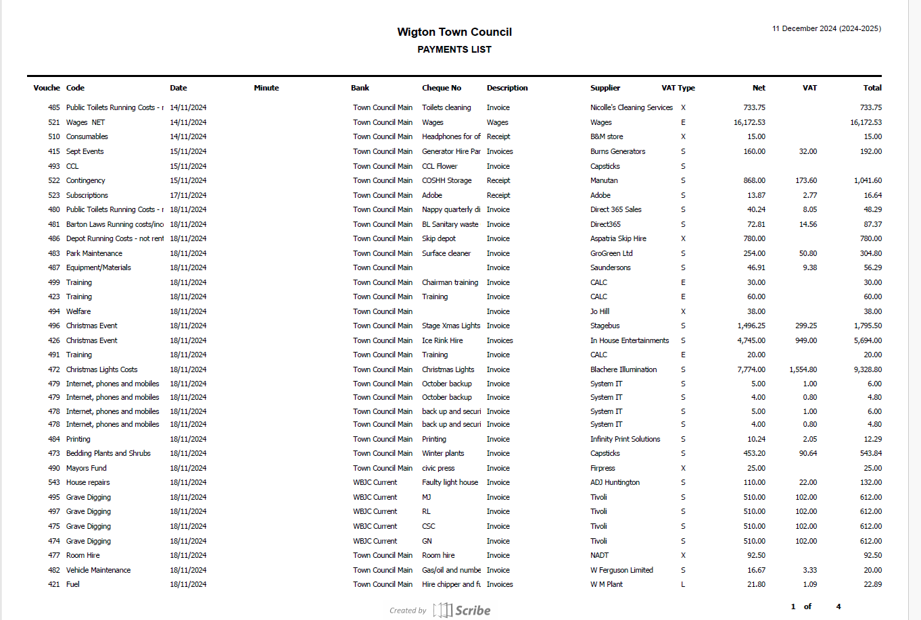

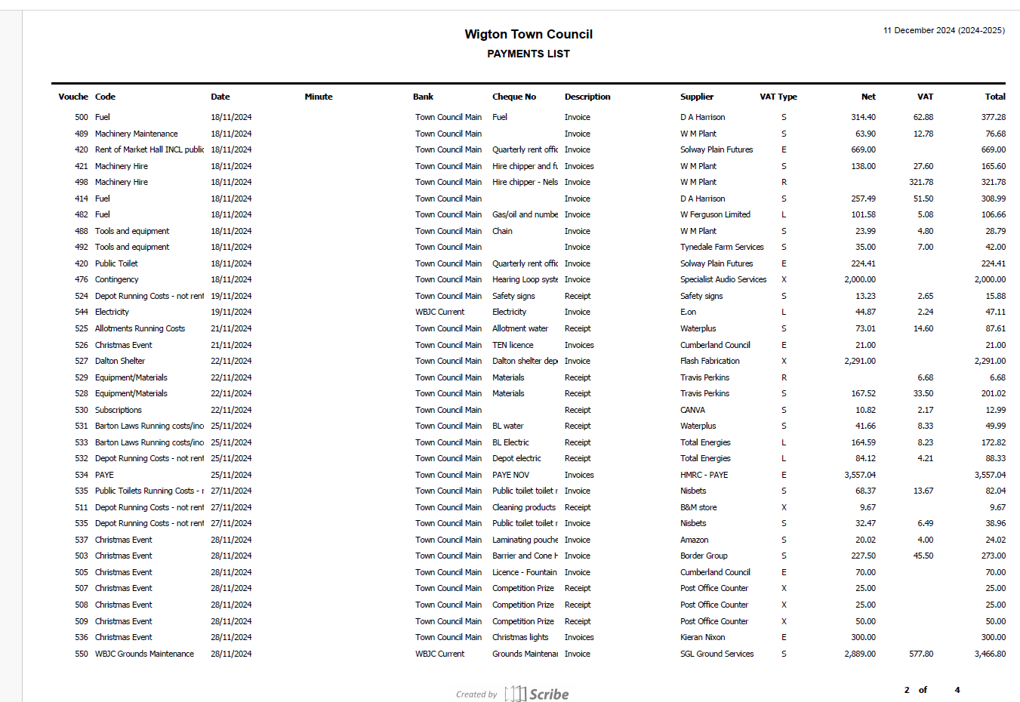

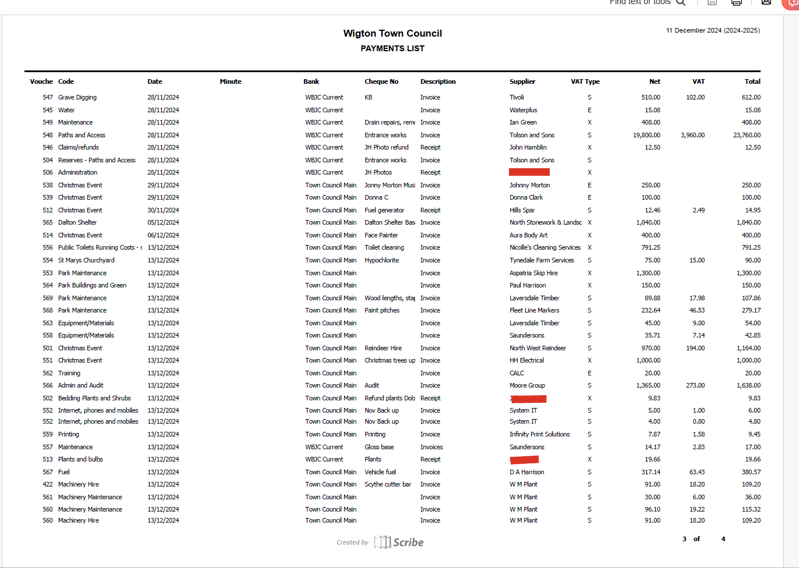

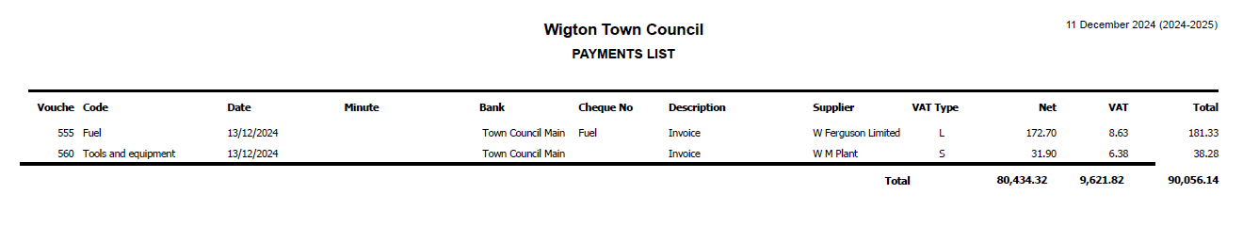
6.2 To decide if the Town Council would like to have a regular awards event that the events committee will plan and manage.

During a finance meeting a member suggested including an awards event in the budget, it was agreed that full council were required to make this decision. A nominal figure was included in the budget until a decision was made. Full council members were asked to vote whether this event would be welcomed and if it were it would be passed to the events committee who would plan the event and feed back to members.

RESOLVED
10 members voted to allow the events committee to plan an awards event. 1 member abstained.

6.3 To review and agree to adopt the 2025/2026 budget.

Prior to this meeting, members were provided with a copy of the 2025/2026 budget that the finance committee had signed off on the 10th December 2024 and a printed version was made available during the meeting. Members were encouraged to ask questions before taking a vote. There was a query around one cost centre as the sum was incorrect, it was identified one of the formulas had an error when printing, but the finance committee had previously had sight of the correct version. Changing the sum had no impact on the overall budget it would just mean estimated reserves might be less.

RESOLVED

Members voted UNANIMOUSLY to adopt the 2025/2026 budget.

6.4 To agree on the precept for 2025/2026.

The required precept amount for 2025/2026 is £420,000. This will be less than a 5% increase to council tax and less than a £10 increase per bill. Exact figures could not be provided without knowing the council tax base which had not yet been released.
RESOLVED
Members UNANIMOUSLY voted to agree the precept will be £420,000 in 2025/2026

FC/96/2024 Committee Spaces

Not all committees were full which has caused some meetings to be inquorate. The committees with spaces were:

Finance – 1 space
Events – 1 space

Members were asked to consider joining committees.

RESOLVED
Cllr Stapley joined the finance committee
Cllr Greenup joined the events committee

FC/97/2024 Grounds Report

Dalston
We have finished all our cuts at Dalston Parish and church, unusually we had to cut in November with all the mild weather as well as finishing off the wildflower areas and cleaning all the leaves up.

We have also been cleaning all the leaves up on all sites.

Wigton park
We have been cleaning the grass on the edges of the paths as well as taking down the old portacabin which we have just finished. It looks a lot better although a bit open so we will be putting up a wooden fence to stop children going behind the old work shed. Work has been going on in the Dalton Shelter which will make a massive difference to its appearance, just the park toilets to do next. All the park shrub beds have been pruned and clipped back and beds mulched.

Wigton Hall
We have been cleaning up, cutting back ivy, clipping back the shrub beds and overgrown areas to tidy it up we just must do the path edges.

Barton Laws and park pitches
The pitches have taken a bit of a battering lately will all the bad weather but with the Christmas break coming they will have a well-earned rest .
Some of our sites have a bit of a mole problem but I'm trying my best to get on top of them.

Throstle Park
We have been moving a lot of the young trees that have seeded beside the pond onto other areas, Frank also made a habitat for insects or small animals so hopefully these trees will take and encourage wildlife to the area.

Me and the lads would like to wish you all a happy Christmas and all the best for the coming year

FC/98/2024 Town Mayor’s Report

See attached.

FC/99/2024 Clerk’s Report

The men’s public toilet door has been subject to constant vandalism as it is regularly kicked in during the weekend. The door has been replaced this year once and the locks have been changed twice. As this continues to happen we need to consider ways in which to prevent the vandalism. We are waiting for a quote to install metal gates outside of the toilets, this quote will be brought to the next meeting for members to discuss. An alternative solution could be to install CCTV, but this will be costly and may not prevent vandalism if the person could not be identified.

There have been issues with the new Christmas lights as there was a delay in getting them all to work. The issues were around the wiring not being done correctly and wrong size fuses. The clerk has spoken with the company and has requested compensation and a meeting to discuss all the issues.

The January meeting should be on the 8th January but this would not allow enough time to prepare all the documents. The clerk asked if the meeting could be moved to the 15th January.

RESOLVED
January full council meeting will be held on Wednesday 15th January.

The clerk informed members that the Christmas lights Ice rink made £770 on the day and Malcolm the Moose made £13. All volunteers were thanked. Future events may require having to pay staff to help as there are never enough volunteers on the day to help which puts pressure on the WTC staff and volunteers that do help.

Members were informed that the Wigton Area Emergency Response Group had recently re-formed and are planning two drop in sessions to ask for volunteers on 25th January from 10-12 in the library and on 29th January from 10-12 at Barton Laws.

FC/100/2024 Member Reports

Cllr Jackson – Attended Wigton Baths AGM, the baths are struggling for funding and trustees. Christmas light switch on. Suggested that we could take card payments at future events.
Cllr Stapley – Christmas lights.
Cllr Clark – Discussed the possibility of hiring a gardener, another member suggested utilising the park staff to maintain flowers beds in the town parks.
Cllr McCarthy – Christmas lights.
Cllr Scott –. Christmas lights.
Cllr Ferriby – Church carol service.
Cllr Speksnyder – Christmas lights and asked how councillors can find out about planning decisions, she was advised to look at the CC website and to look out for emails from the office.
Cllr Hamblin – showed members his Cumbria in Bloom award and raised that volunteers would be required to look after the flower beds in the future. Cllr Hodson thanked Cllr Hamblin for all the work he put in.

Meeting Closed – 20:41pm

Date of next meeting: Wednesday 15th January 2024

